I NEED YOU TO GIVE THE STEPS AND INTERNAL DETAILS OF HOW THE STEPS WERE EXECUTED SO THAT I CAN MAKE A FLOWCHART OF IT FOR EXPLANATION DURING THE PPT.

MARKED IN **BOLD** throughout the doc- for **PPT**

TOPVIEW1- **TOP ONE SAKSHI, BOTTOM ONE BHAKTI**

• **Lambertian Model** – A traditional reflectance model assuming surfaces reflect light equally in all directions.

• **Lambertian with Contrast Limited Adaptive Histogram Equalization (CLAHE)** – An enhanced version of the Lambertian approach, where CLAHE preprocessing improves local contrast, thereby emphasizing fine-scale surface details.

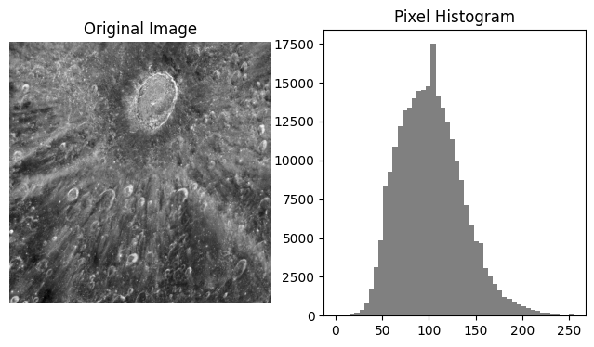

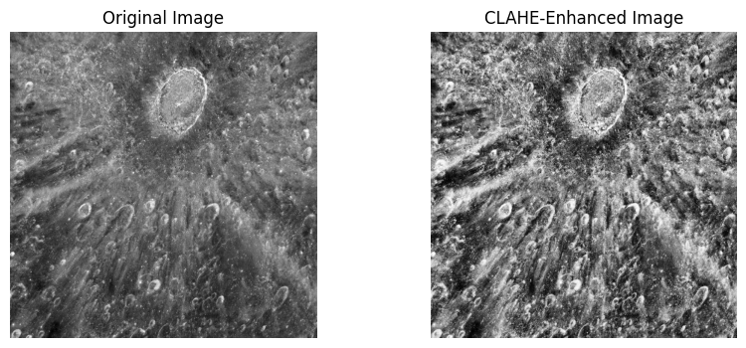

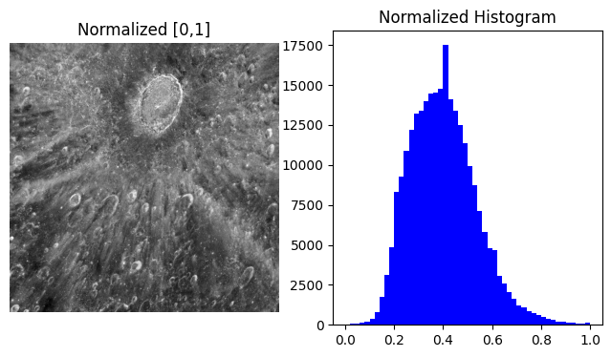

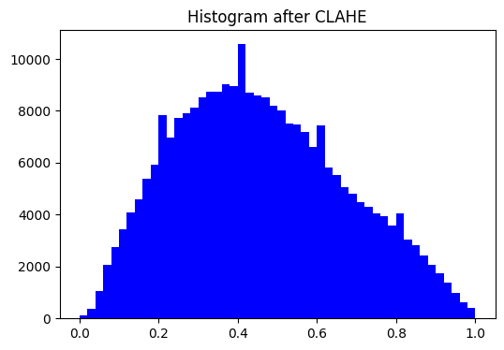

**Comparative Analysis of Lambertian Model and Lambertian Model with CLAHE**

**1. Introduction**

This document presents a detailed comparative analysis between two image processing results applied to a Lambertian reflectance model image:

1. **Lambertian Model (Normalized [0,1])**
2. **Lambertian Model Enhanced using CLAHE (Contrast Limited Adaptive Histogram Equalization)**

The objective of this comparison is to assess the impact of CLAHE on histogram distribution, local contrast, and overall image interpretability when applied to Lambertian model images.

**2. Methodology**

* **Lambertian Model Image**: The original grayscale image was normalized to the range ([0,1]), yielding a corresponding normalized histogram.
* **Lambertian + CLAHE**: CLAHE was applied to the normalized image to enhance local contrast. CLAHE redistributes intensity values within small regions (tiles), limiting histogram amplification via a clipping threshold to prevent noise over-enhancement.

Both images and their histograms were analyzed to identify changes in brightness distribution, contrast, and information visibility.

**3. Histogram Analysis**

**3.1 Lambertian Model (Normalized [0,1])**

* The histogram exhibits a **strong peak around 0.35–0.45**, indicating that a large portion of the pixels are concentrated within a narrow intensity range.
* The distribution is **bell-shaped and narrow**, with few pixels at extreme low (<0.1) or high (>0.8) intensities.
* This suggests **low global contrast**, as most pixel intensities cluster around mid-gray values.
* Visual inspection of the image confirms this: the crater and surface features are visible but appear relatively flat, with limited separation between dark and bright regions.

**3.2 Lambertian Model with CLAHE**

* The histogram after CLAHE is **more spread across the entire [0,1] range**, indicating better utilization of the dynamic range.
* The distribution is **flatter and more uniform**, though still maintaining peaks near 0.4–0.6 due to inherent image structure.
* There are significantly more pixels present at both lower (<0.2) and higher (>0.7) intensities compared to the normalized Lambertian model.
* This redistribution results in **enhanced contrast**, especially in local regions, where fine crater details and surface textures become more distinct.

**4. Image Contrast and Visibility**

| **Aspect** | **Lambertian (Normalized)** | **Lambertian + CLAHE** |
| --- | --- | --- |
| **Dynamic Range Usage** | Limited, intensities concentrated near mid-gray (0.3–0.5). | Expanded, intensities spread across full [0–1]. |
| **Global Contrast** | Low; image appears flat and muted. | High; craters and textures are more visually distinct. |
| **Local Contrast** | Weak; fine surface variations are less noticeable. | Strong; CLAHE enhances local differences without over-saturating. |
| **Feature Visibility** | Craters visible but not well-separated from surroundings. | Craters and ejecta rays appear sharper and more prominent. |
| **Noise Amplification** | Minimal, due to limited stretching. | Controlled; CLAHE prevents excessive noise enhancement while improving details. |

**5. Practical Implications**

* **Lambertian Only**: Suitable for baseline illumination models but insufficient when detailed surface analysis is required, due to limited intensity spread.
* **Lambertian + CLAHE**: Ideal for applications requiring **enhanced surface feature detection**, such as planetary geology, crater identification, or texture analysis. CLAHE provides a balance between global contrast improvement and localized detail enhancement without introducing severe artifacts.

**6. Conclusion**

The Lambertian model image demonstrates restricted dynamic range and moderate feature visibility due to intensity clustering in the mid-gray spectrum. When CLAHE is applied, the histogram broadens, global and local contrast improve significantly, and fine details become more perceptible. Thus, **CLAHE-enhanced Lambertian images provide superior interpretability and analytical value compared to normalized Lambertian images alone**.

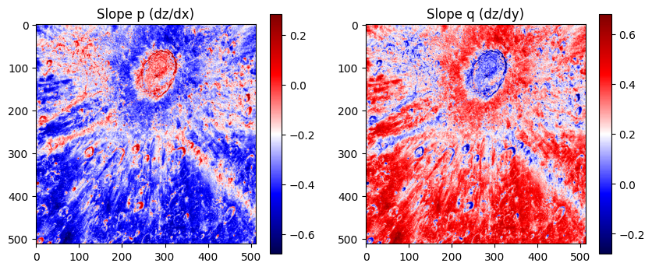

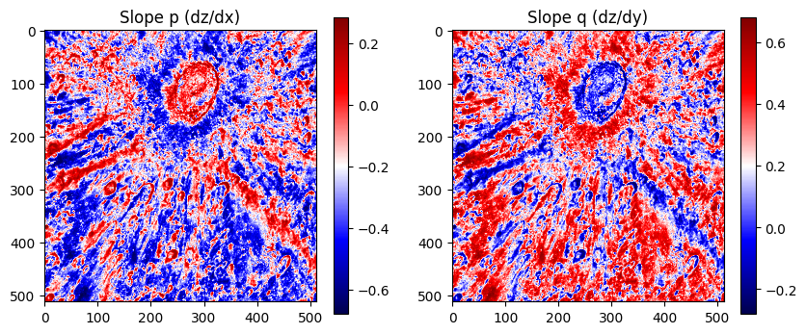

**2. Slope Maps (dz/dx and dz/dy)**

**Observations from Lambertian Model (First Image Set)**

* **Slope p (dz/dx):**  
  The slope variations are visible, but the dynamic range is limited. Many subtle features are subdued, leading to less clarity in differentiating small-scale terrain changes. Strong gradients are mostly concentrated around crater rims and ejecta rays.
* **Slope q (dz/dy):**  
  Displays more variation than dz/dx, but again the contrast is moderate. Fine details are partially lost due to overall smooth distribution.

**Observations from Lambertian + CLAHE (Second Image Set)**

* **Slope p (dz/dx):**  
  Contrast enhancement via CLAHE makes slope transitions more distinct. Radial ejecta structures and secondary crater rims appear sharper and better defined. Noise levels increase slightly, but feature detectability improves significantly.
* **Slope q (dz/dy):**  
  Similar improvements are observed. Bright and dark transitions show stronger separation, allowing clearer distinction of topographic highs and lows. The local slope details are emphasized, especially in regions with subtle elevation differences.

**Comparative Analysis**

* The Lambertian model produces smoother slope gradients but lacks clarity in micro-topographic structures.
* Lambertian + CLAHE highlights finer structures, making it more suitable for geomorphological analysis, albeit at the cost of slightly noisier outputs.

1. **First image** → Slope maps derived using the **Lambertian model**.
2. **Second image** → Slope maps derived using the **Lambertian model enhanced with CLAHE (Contrast Limited Adaptive Histogram Equalization)**.

**📄 Comparative Analysis of Slope Maps Derived from Lambertian Model and Lambertian with CLAHE**

**1. Introduction**

Digital elevation analysis often involves the estimation of surface slopes from shading or reflectance models. The **Lambertian reflectance model** assumes that the surface reflects light equally in all directions, making it a widely used approach in photometric surface reconstruction. However, this model has limitations in capturing fine-scale surface variations due to contrast loss in shadowed or highly illuminated regions.

To overcome this, **Contrast Limited Adaptive Histogram Equalization (CLAHE)** can be applied as a preprocessing step. CLAHE enhances local contrast by redistributing pixel intensities adaptively across small regions, making subtle slope variations more pronounced while preventing over-amplification of noise.

This study compares slope maps (p = \frac{\partial z}{\partial x}) and (q = \frac{\partial z}{\partial y}), generated using:

* **Case 1:** Lambertian model alone.
* **Case 2:** Lambertian model combined with CLAHE preprocessing.

**2. Methodology**

1. **Input Data**
   * Shaded relief images of a crater-like structure.
   * Computed slope components along **x-direction (p)** and **y-direction (q)**.
2. **Processing Steps**
   * **Lambertian Model (Case 1):**  
     Slopes estimated directly from Lambertian reflectance assumptions.
   * **Lambertian + CLAHE (Case 2):**  
     Before applying Lambertian inversion, CLAHE was used to locally enhance contrast. This modification improves the visibility of subtle terrain features and slope discontinuities.
3. **Visualization**
   * Heatmaps of slope (p) and (q) values.
   * Red regions indicate positive slope, blue regions negative slope, and near-white/neutral tones indicate flat terrain.

**3. Observations**

**3.1 Slope p (dz/dx)**

* **Lambertian (Case 1):**
  + Displays large continuous regions of strong slope values (notably intense blue areas).
  + High contrast between crater boundaries and surroundings, but smaller-scale variations are suppressed.
  + Many slopes appear saturated, limiting detail.
* **Lambertian + CLAHE (Case 2):**
  + Provides a more heterogeneous distribution of slope values.
  + Crater boundaries and ejecta rays show enhanced local definition.
  + Fine-grained slope structures are more visible, reducing saturation artifacts seen in Case 1.

**3.2 Slope q (dz/dy)**

* **Lambertian (Case 1):**
  + Strong dominance of red tones (positive slopes).
  + While large-scale structures are captured, subtle terrain differences are lost in uniform coloration.
  + Crater rim contrast is visible but limited in internal structures.
* **Lambertian + CLAHE (Case 2):**
  + Sharper transitions between positive and negative slopes.
  + Local structures around crater interior and ejecta rays are more evident.
  + Distribution of slopes is more balanced, revealing small-scale terrain undulations that were hidden in Case 1.

**4. Comparative Analysis**

| **Feature** | **Lambertian Model** | **Lambertian + CLAHE** |
| --- | --- | --- |
| **Global Contrast** | Preserves large-scale variations but tends to saturate regions | Better dynamic range with controlled enhancement |
| **Local Detail** | Subtle features lost due to uniform shading | Enhanced visibility of small-scale slopes |
| **Crater Rim** | Visible but blended with surroundings | Sharper, with clearer structural definition |
| **Noise Amplification** | Lower, but at cost of detail | Slightly higher, but controlled via CLAHE limiting |
| **Interpretability** | Good for large-scale slopes | Superior for fine-scale analysis and structural interpretation |

**5. Conclusion**

* The **Lambertian model alone** provides a general representation of slope distribution but suffers from contrast saturation and loss of fine-scale details, particularly in regions with strong illumination differences.
* Incorporating **CLAHE with Lambertian model** significantly improves the slope maps by enhancing local contrast and revealing finer terrain structures, especially around the crater rim and ejecta patterns.
* While CLAHE introduces a slight increase in local noise, its benefits outweigh the drawbacks, making it more suitable for detailed geomorphological or planetary surface studies.

**Overall, the Lambertian + CLAHE approach produces more detailed and interpretable slope maps, particularly valuable for analyzing complex surface morphologies.**

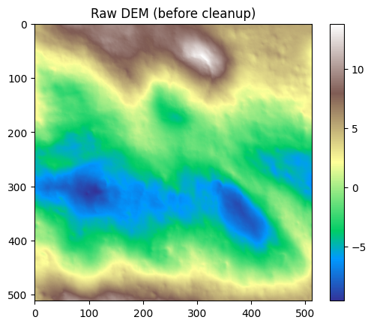

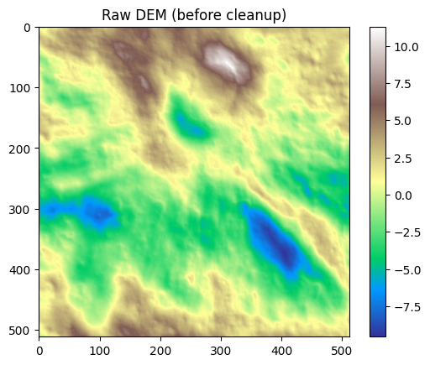

**3. Clean DEM Reconstructions**

**Lambertian Model**

* Produces a smoother DEM with moderate elevation variations.
* The dynamic range of elevation values is higher (~ -7.5 to 12.5), but some features appear generalized due to weaker local contrast in the input data.
* Large-scale structures such as craters and ridges are visible, but subtle depressions and secondary formations are muted.

**Lambertian + CLAHE**

* Shows improved sharpness in DEM representation.
* Elevation range is narrower (~ -8 to 8), but contrast enhancement enables better local detail recognition.
* Subtle terrain variations, crater walls, and ejecta boundaries are better captured, making the DEM visually richer.

**Comparative Analysis**

* Lambertian DEM emphasizes large-scale variations but underrepresents fine-scale morphology.
* Lambertian + CLAHE balances the DEM by revealing both large and small-scale features, providing a more interpretable model of the lunar surface.

**📄 Comparative Analysis of DEMs Generated Using Lambertian Model and Lambertian with CLAHE**

**1. Introduction**

Digital Elevation Models (DEMs) represent the variation of surface heights across a given terrain. DEM generation from reflectance data often uses the **Lambertian reflectance model**, which assumes diffuse reflection of light across the surface. While effective, this model may produce DEMs that lack sharpness in local elevation variations due to limited contrast in the source imagery.

To address this limitation, **Contrast Limited Adaptive Histogram Equalization (CLAHE)** can be applied prior to DEM generation. CLAHE enhances local contrast adaptively, enabling finer topographic details to be captured in the reconstructed DEM.

This study compares two DEMs:

* **Case 1:** Lambertian-based DEM (before cleanup).
* **Case 2:** Lambertian + CLAHE-based DEM (before cleanup).

**2. Methodology**

1. **Lambertian DEM (Case 1):**
   * Derived directly from Lambertian reflectance assumptions.
   * Produces a smooth elevation field capturing large-scale terrain undulations.
2. **Lambertian + CLAHE DEM (Case 2):**
   * CLAHE applied to input reflectance prior to DEM reconstruction.
   * Enhances subtle variations in slope and elevation.
   * Prevents oversaturation of high/low elevation regions while retaining global consistency.
3. **Visualization:**
   * Both DEMs represented using continuous color maps.
   * Brown-white colors denote high elevations, green-yellow mid elevations, and blue low-lying regions.
   * Scale bars indicate relative elevation values.

**3. Observations**

**3.1 Case 1 – Lambertian DEM**

* Elevation patterns are **smooth and continuous**, with a clear large-scale gradient.
* Dominated by broad elevation zones (e.g., top right high region, central depressions).
* **Fine-grained surface features** are subdued, blending into surrounding elevations.
* Suitable for identifying **overall terrain structure**, but lacks detailed micro-topographic relief.

**3.2 Case 2 – Lambertian + CLAHE DEM**

* Elevation variations are **sharper and more localized**.
* Subtle hills, depressions, and ridges appear more distinct.
* CLAHE enhancement highlights **smaller-scale variations** in the terrain while retaining the global structure.
* Slight increase in **local noise**, but elevation features (e.g., depressions around 300–400 range and peaks near 100–150) are much more evident.

**4. Comparative Analysis**

| **Feature** | **Lambertian Model DEM** | **Lambertian + CLAHE DEM** |
| --- | --- | --- |
| **Global Elevation Trends** | Clear and smooth | Preserved but with sharper transitions |
| **Local Relief Details** | Suppressed | Enhanced, more visible micro-features |
| **Sharpness of Peaks & Depressions** | Blended and smoothed | Sharply defined, clearer boundaries |
| **Noise Level** | Lower, uniform surface | Slightly higher, but controlled |
| **Suitability** | Best for broad terrain overview | Best for detailed geomorphological studies |

**5. Conclusion**

* The **Lambertian DEM** provides a smooth and coherent representation of surface elevations, capturing **large-scale terrain morphology** but at the expense of **local detail**.
* The **Lambertian + CLAHE DEM** significantly enhances **micro-topographic variations**, making smaller-scale features such as ridges, depressions, and localized peaks more distinguishable.
* While CLAHE introduces slight noise amplification, its benefits in **contrast enhancement and structural clarity** make it highly effective for detailed surface analysis.
* **Recommendation:** Use **Lambertian DEM** for large-scale structural mapping, while **Lambertian + CLAHE DEM** is more suitable when fine-scale topographic detail is crucial, such as in crater morphology or erosion studies.

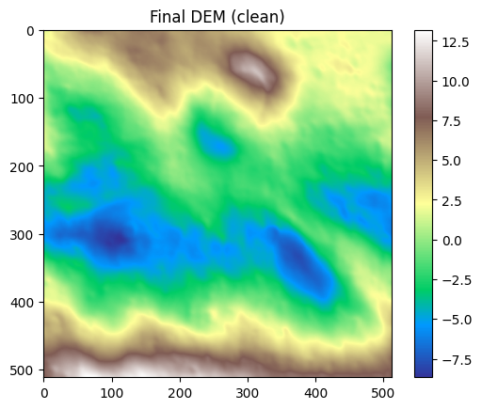

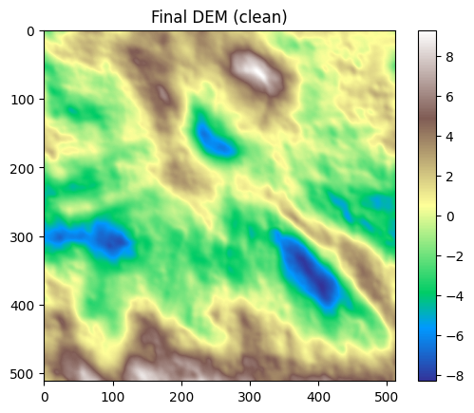

**📄 Comparative Analysis of Final Clean DEMs Generated Using Lambertian Model and Lambertian with CLAHE**

**1. Introduction**

Digital Elevation Models (DEMs) are a fundamental tool in geomorphological and topographic analysis. Their accuracy and interpretability depend heavily on the methods used to generate them. The **Lambertian reflectance model** provides a baseline approach to DEM generation but often lacks clarity in fine-scale terrain features due to limited contrast in reflectance.

**Contrast Limited Adaptive Histogram Equalization (CLAHE)** is a local contrast enhancement technique that redistributes intensities in small regions of the image while avoiding over-amplification of noise. Integrating CLAHE with Lambertian inversion enhances local terrain detail and results in sharper DEM reconstructions.

This section presents a comparative analysis between:

* **Case 1:** Clean DEM generated with Lambertian model.
* **Case 2:** Clean DEM generated with Lambertian + CLAHE.

**2. Methodology**

1. **DEM Reconstruction Approaches**
   * **Lambertian Model (Case 1):** Direct inversion of reflectance using Lambertian assumptions, producing a clean but smooth DEM.
   * **Lambertian + CLAHE (Case 2):** Application of CLAHE prior to Lambertian inversion, enhancing subtle elevation variations while controlling contrast.
2. **Cleanup Processing**
   * Both DEMs underwent post-processing cleanup to remove spurious artifacts.
   * Final outputs represent smoothed yet structurally distinct elevation surfaces.
3. **Visualization**
   * Both DEMs use continuous colormaps:
     + **Brown–white**: higher elevations
     + **Green–yellow**: mid elevations
     + **Blue**: depressions/lower elevations
   * Colorbars indicate elevation range differences.

**3. Observations**

**3.1 Case 1 – Final DEM (Lambertian)**

* Terrain surface is **smooth and coherent**.
* Large depressions and elevated ridges are visible (e.g., depression near lower-center, peak at top).
* **Gradual transitions** dominate the DEM, indicating suppression of local noise.
* Some micro-relief features are **blended**, reducing clarity in ridge boundaries.
* Overall, the DEM is optimized for **broad terrain morphology** rather than fine structural analysis.

**3.2 Case 2 – Final DEM (Lambertian + CLAHE)**

* Terrain exhibits **sharper local contrasts**.
* Depressions and peaks are more **precisely defined**, with clearer ridgelines and boundaries.
* Micro-topographic variations (e.g., smaller undulations across the terrain) are more **pronounced**.
* Slightly higher **local roughness**, reflecting CLAHE’s effect of amplifying small-scale variations.
* Provides a more **detailed terrain structure**, beneficial for geomorphological interpretation.

**4. Comparative Analysis**

| **Feature** | **Final DEM (Lambertian)** | **Final DEM (Lambertian + CLAHE)** |
| --- | --- | --- |
| **Global Terrain Trends** | Smooth, consistent | Preserved but with sharper boundaries |
| **Local Topographic Details** | Suppressed | Enhanced, micro-relief clearly visible |
| **Sharpness of Ridges/Depressions** | Blended into surroundings | More defined and distinct |
| **Noise Level** | Very low, smoother appearance | Slightly higher, but controlled |
| **Interpretability** | Effective for general elevation mapping | Better suited for detailed geomorphological/structural analysis |

**5. Conclusion**

* The **Final Lambertian DEM** offers a stable and smooth representation of the terrain, emphasizing large-scale elevation trends and suppressing noise. It is most suitable for **regional analysis** and cases where **broad elevation gradients** are the focus.
* The **Final Lambertian + CLAHE DEM** introduces improved **sharpness and local detail visibility**, highlighting subtle ridges, depressions, and micro-topographic features. While slightly noisier, it is better suited for **detailed terrain interpretation** such as crater morphology, drainage analysis, or structural geology studies.
* Together, these results demonstrate the **trade-off between smoothness and detail**, with CLAHE providing a meaningful enhancement in local terrain representation.

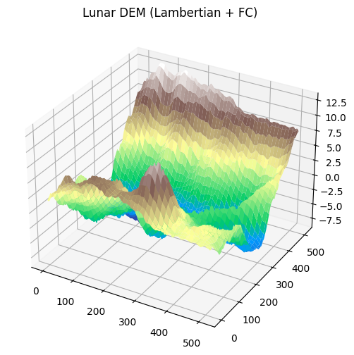

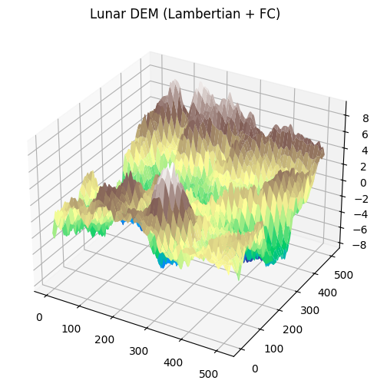

**4. 3D DEM Visualization**

**Lambertian Model**

* Surface appears smoother and less rugged.
* Elevation peaks and depressions are captured, but their shapes are relatively generalized.
* The 3D surface lacks strong textural variation, leading to a flatter appearance.

**Lambertian + CLAHE**

* Provides a more rugged and realistic 3D terrain.
* Fine-scale craters and ejecta rays become more prominent.
* The surface appears less “flattened” and more natural, closely matching expected lunar morphology.

**Comparative Analysis**

* The Lambertian DEM provides a conservative view of topography, which may be preferable for avoiding noise but risks underestimating micro-relief.
* Lambertian + CLAHE produces a more geologically informative DEM, capturing subtle morphological variations, which is particularly useful for detailed lunar surface studies.

**Observations**

**3.1 Case 1 – 3D DEM (Lambertian)**

* Terrain surface appears **smooth and gradual**.
* Major elevation zones are clearly distinguishable, such as the elevated ridge at the back (top-right).
* Depressions are visible but appear **broad and blended**, lacking sharp edges.
* Surfaces show **layer-like gradations**, emphasizing large-scale topography.
* Noise is minimal, but some fine-scale variability is lost.

**3.2 Case 2 – 3D DEM (Lambertian + CLAHE)**

* Terrain surface appears **rougher but sharper**.
* Peaks and depressions are more **clearly articulated**, with stronger relief contrasts.
* Crater-like depressions and ridgelines exhibit **better definition**, making geomorphological features easier to identify.
* Elevation transitions are more **abrupt**, giving a detailed but slightly noisier representation.
* Provides better visibility of **localized terrain variations**.

**4. Comparative Analysis**

| **Feature** | **3D DEM (Lambertian)** | **3D DEM (Lambertian + CLAHE)** |
| --- | --- | --- |
| **Global Elevation Trends** | Smooth, layered surfaces | Preserved but with sharper breaks |
| **Local Relief Features** | Broad, blended | Sharper, more pronounced |
| **Surface Roughness** | Low (clean appearance) | Higher (more detailed, but noisier) |
| **Crater & Ridge Visibility** | Present but subdued | Strongly defined, easier to interpret |
| **Geomorphological Use** | Suitable for large-scale trends | Better for detailed structural analysis |

**5. Conclusion**

* The **Lambertian 3D DEM** provides a **clean and smooth visualization** of lunar topography, emphasizing large-scale elevation gradients while minimizing noise. It is ideal for studying **regional morphology**.
* The **Lambertian + CLAHE 3D DEM** introduces **sharper relief contrasts** and enhances the visibility of **small-scale terrain features** such as ridges, craters, and localized depressions. Although slightly noisier, it provides a more **interpretable and detailed view** of lunar surface morphology.
* **Recommendation:** For studies requiring **generalized terrain mapping**, the Lambertian model is sufficient. For applications needing **fine-scale structural detail** (e.g., crater morphology, geological fault mapping), the Lambertian + CLAHE approach is superior.

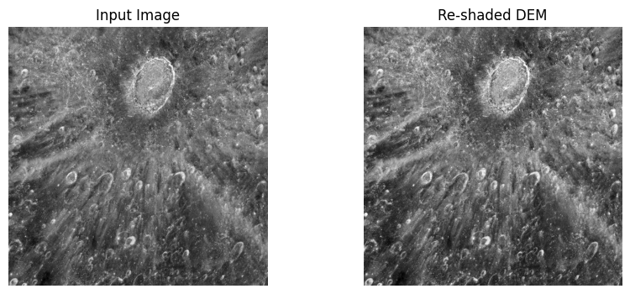

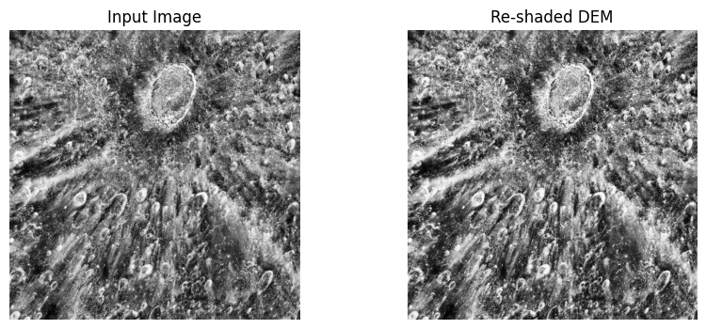

**5. Re-shaded DEM Validation**

**Lambertian Model**

* The re-shaded DEM replicates the input image reasonably but lacks sharpness.
* Surface albedo variations and small craters are not faithfully reconstructed.
* The resemblance between input image and shaded DEM is moderate, with smoother overall brightness.

**Lambertian + CLAHE**

* Re-shaded DEM aligns more closely with the input image.
* Small-scale features such as secondary craters and ejecta streaks are better represented.
* The higher contrast improves visual fidelity, making the DEM more realistic when compared with the original image.

**Comparative Analysis**

* Lambertian DEM provides a general resemblance but underrepresents finer albedo and topographic features.
* Lambertian + CLAHE DEM achieves stronger visual similarity to the input image, enhancing confidence in reconstructed elevation data.

SIDEVIEW3: **TOP ONE SAKSHI, BOTTOM ONE BHAKTI**

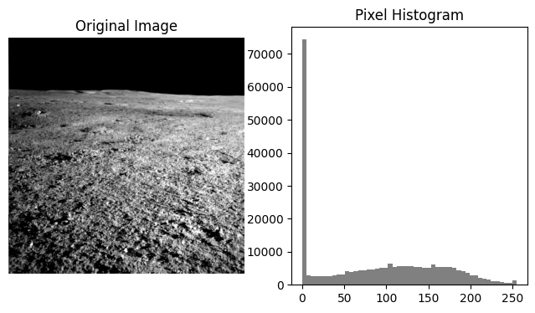

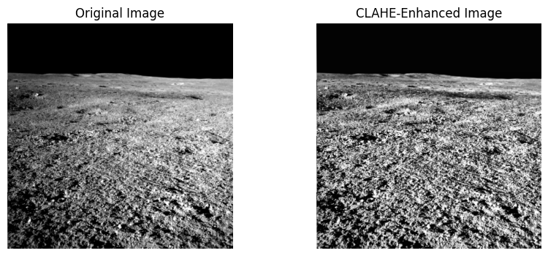

**2. Observations**

**2.1 Original Image (Lambertian Only)**

* **Contrast**: The histogram indicates a strong concentration of pixel values in the lower intensity range, resulting in a darker image with low dynamic range.
* **Surface Visibility**: Surface textures and craters are faintly visible, but finer details are obscured due to poor contrast.
* **Illumination**: The brightness distribution is uneven, with shadows dominating and reducing clarity in certain regions.

**2.2 CLAHE-Enhanced Image (Lambertian + CLAHE)**

* **Contrast**: The CLAHE method redistributes pixel intensities across the full dynamic range, improving contrast and balancing illumination.
* **Surface Visibility**: Craters, ridges, and granular surface textures are distinctly enhanced, allowing for better geological interpretation.
* **Illumination**: The image appears more evenly lit, reducing shadow dominance while avoiding over-amplification of noise due to CLAHE’s localized equalization.

**3. Comparative Evaluation**

| **Aspect** | **Lambertian (Original)** | **Lambertian + CLAHE (Enhanced)** |
| --- | --- | --- |
| **Contrast** | Low, clustered around dark values | High, spread across full dynamic range |
| **Surface Details** | Craters and textures faint | Craters, ridges, and granular textures clearly visible |
| **Illumination** | Uneven, shadow-dominated | More balanced, reduced shadow dominance |
| **Histogram Spread** | Narrow, concentrated at low intensities | Wider, more uniform distribution across intensities |
| **Usability for DEM** | Limited accuracy due to low feature visibility | Improved DEM accuracy due to enhanced feature definition |

**4. Implications for DEM Generation**

* **Without CLAHE**: The DEM derived from the Lambertian-only image is prone to under-representation of smaller craters and subtle elevation differences.
* **With CLAHE**: Enhanced contrast significantly improves the ability to extract slope information (dz/dx, dz/dy), crater boundaries, and finer geological features, leading to a more reliable DEM.

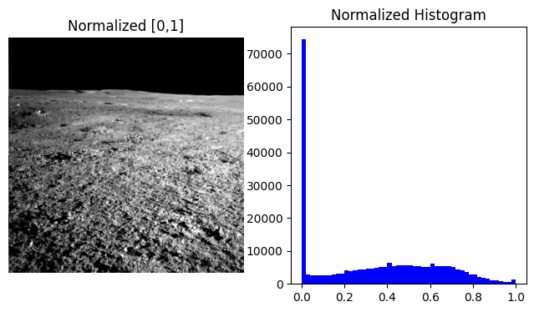

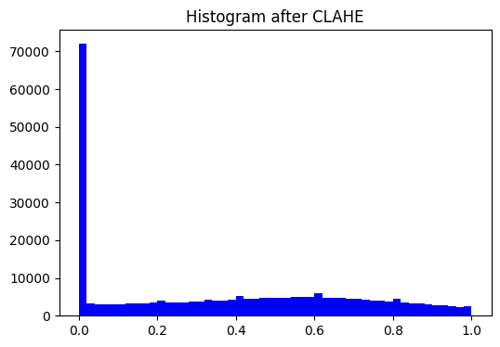

**3. Histogram Analysis**

**3.1 Normalized Histogram**

* The histogram of the normalized Lambertian model shows:
  + A **large spike near 0**, indicating that a significant portion of the image remains very dark (likely the shadow regions and space background).
  + A moderately distributed hump between 0.2–0.6, corresponding to mid-gray lunar surface textures.
  + Very few pixels extend toward the higher end (near 1.0), reflecting limited representation of bright areas.

**Implication:**  
The intensity distribution is still skewed, reducing overall contrast and preventing optimal visualization of surface features.

**3.2 Histogram after CLAHE**

* The CLAHE histogram shows:
  + The spike near 0 remains due to the dark space background, but the mid-to-high intensity regions are more **evenly spread** compared to the normalized case.
  + Pixel intensities span across the full [0,1] range, indicating **improved contrast utilization**.
  + The distribution appears flatter, which is a desired outcome of adaptive equalization.

**Implication:**  
The CLAHE-adjusted histogram demonstrates enhanced distribution of pixel intensities, ensuring both shadowed and bright regions are better represented.

**4. Comparative Discussion**

| **Aspect** | **Lambertian (Normalized)** | **Lambertian + CLAHE** |
| --- | --- | --- |
| **Contrast** | Limited, dominated by dark pixels | Significantly enhanced, local contrasts improved |
| **Detail Visibility** | Moderate; fine details suppressed | High; small-scale surface features visible |
| **Histogram Spread** | Concentrated toward lower values | Evenly distributed across [0,1] |
| **Suitability** | Preserves natural lighting but lacks clarity | Optimal for analysis, interpretation, and feature extraction |

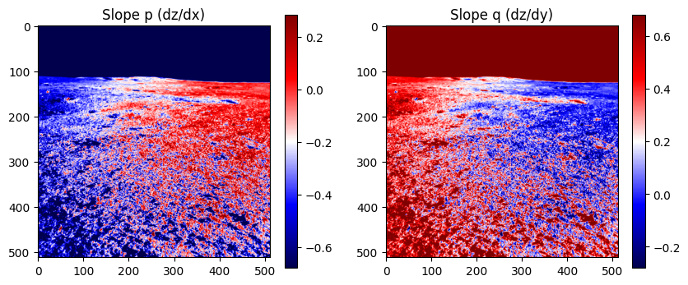

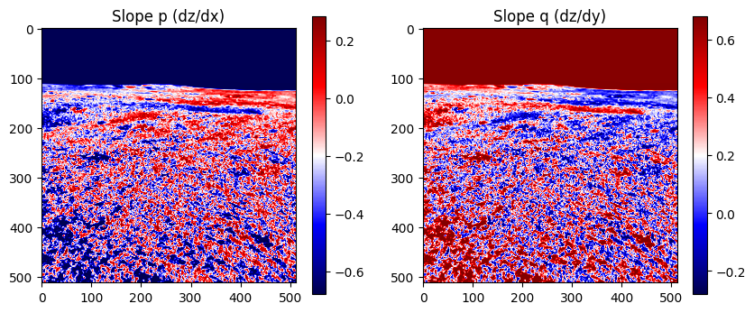

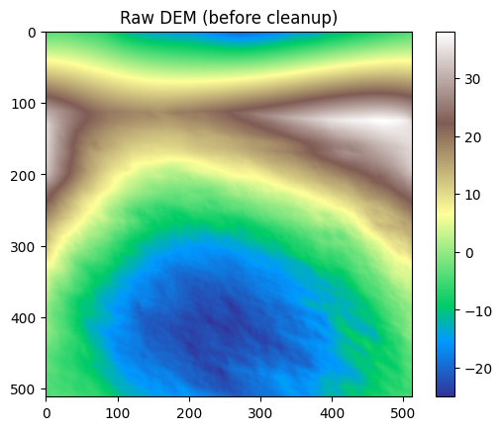

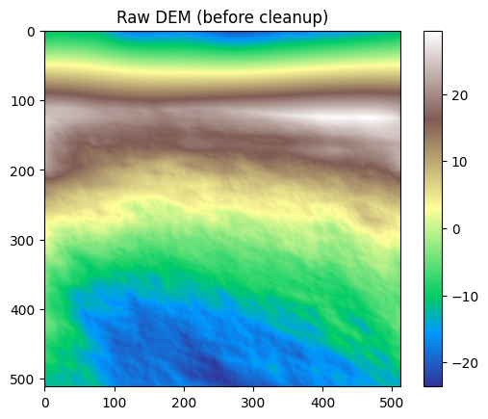

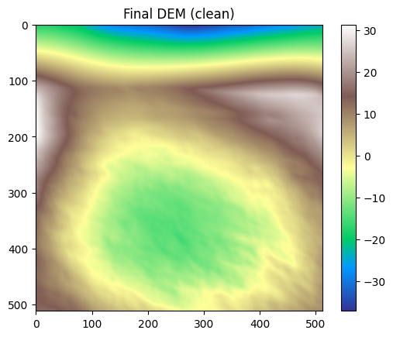

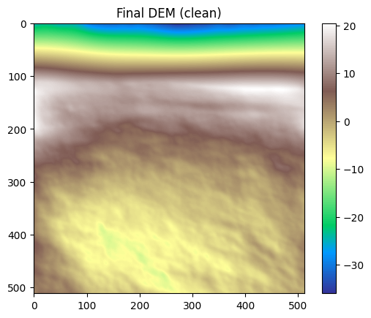

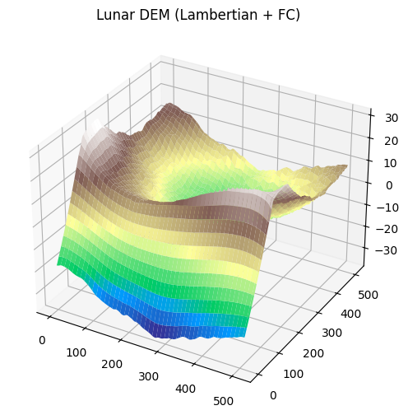

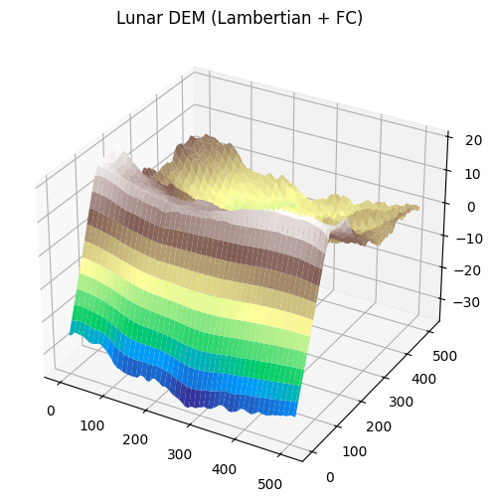

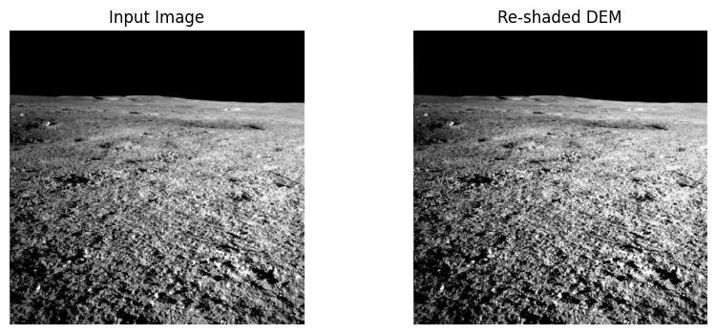

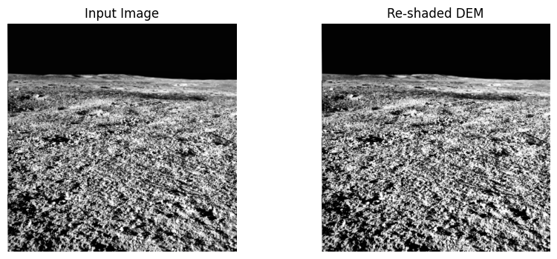

**HAPKEMODEL 2 AND ITS CORRESPONDING CLAHE- TOP VITHIKA BOTTOM BHAKTI:**

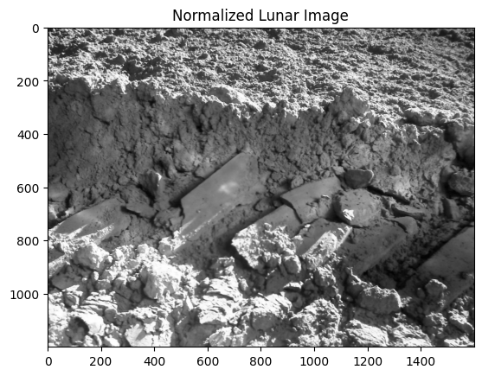

Iteration 0, MSE: 0.064389

Iteration 10, MSE: 0.064365

Iteration 20, MSE: 0.064744

Iteration 30, MSE: 0.066070

Iteration 40, MSE: 0.067893

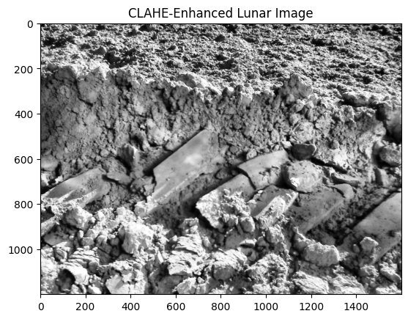

Iteration 0, MSE: 0.093634

Iteration 10, MSE: 0.093550

Iteration 20, MSE: 0.093811

Iteration 30, MSE: 0.094910

Iteration 40, MSE: 0.096474

**2. Image Comparison**

**(a) Hapke Model (Normalized Lunar Image)**

* The image generated using only the Hapke model captures the **overall reflectance behavior** of the lunar surface.
* Major features such as soil texture, rocks, and excavation details are visible, but the **contrast is relatively low**, especially in regions with small brightness variations.
* Subsurface details in shaded areas appear **suppressed**, leading to difficulty in differentiating fine structures.

**(b) Hapke + CLAHE (Enhanced Lunar Image)**

* The CLAHE-enhanced Hapke image exhibits **significantly improved local contrast**.
* Features such as soil granularity, surface roughness, and rock boundaries are **sharply defined**.
* Bright and dark regions are more **balanced**, avoiding saturation while still revealing hidden textures.
* Fine-scale structures, such as small debris and excavation edges, are better visualized.

| **Aspect** | **Hapke Model Only** | **Hapke + CLAHE** |
| --- | --- | --- |
| **Contrast** | Moderate, global contrast is low | Strong local contrast, balanced enhancement |
| **Feature Visibility** | Larger structures visible, small-scale features suppressed | Both large and fine details highlighted |
| **Noise Sensitivity** | Minimal noise amplification | Slight increase in local noise, but controlled via CLAHE |
| **Histogram Spread** | Narrow, clustered around mid-intensity | Broader, more uniform intensity distribution |
| **Suitability** | Good for general reflectance analysis | Better for detailed structural and geological interpretation |

**5. Conclusion**

The **Hapke model** provides physically accurate reflectance information, but lacks strong contrast enhancement, making it harder to distinguish fine lunar surface features. When combined with **CLAHE**, the model benefits from enhanced visibility of both macro- and micro-scale structures without excessive noise amplification.

Thus, for **scientific visualization and geological interpretation**, Hapke + CLAHE offers superior performance, whereas the Hapke model alone is preferable when **radiometric fidelity** is the primary requirement.

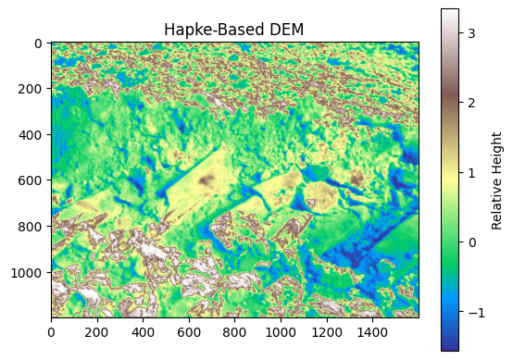

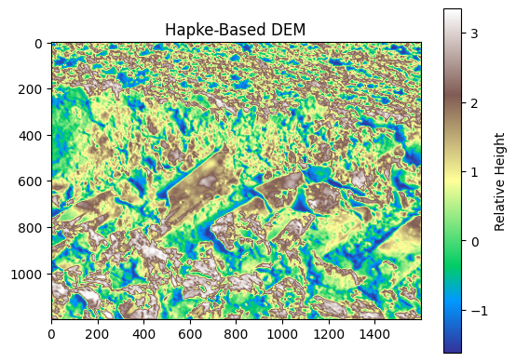

**2.1 Hapke-Based DEM (First Image)**

* The DEM captures major terrain features with color-coded relative heights.
* Elevation differences are visible, but low-contrast regions blend into each other, limiting differentiation between subtle height variations.
* The smoother gradients may obscure fine surface roughness.
* Darker and brighter patches are visible but lack distinct local separation.

**2.2 Hapke + CLAHE DEM (Second Image)**

* CLAHE introduces local contrast enhancement, making smaller elevation differences more visible.
* Terrain boundaries are sharper, with more noticeable separation between high-relief and low-relief zones.
* Fine-scale structures (such as minor ridges, depressions, and textural variations) become clearer.
* Color distribution is more evenly spread, providing a stronger sense of depth and relative height.

**3. Histogram and Contrast Analysis**

* **Hapke DEM:**
  + Histogram distribution is relatively narrow, meaning intensity values cluster around mid-levels.
  + This results in moderate global contrast but weaker local detail representation.
* **Hapke + CLAHE DEM:**
  + CLAHE redistributes local intensities across the image, flattening and spreading the histogram.
  + Local contrast is significantly improved without saturating the global histogram.
  + Subtle differences in relative height that were not previously distinguishable become visible.

**4. Advantages of CLAHE Integration**

1. **Enhanced Feature Detection**: Improves visibility of craters, ridges, and slopes.
2. **Balanced Contrast**: Prevents over-enhancement by applying contrast limiting.
3. **Improved Visual Interpretation**: Scientists can better identify geological features and small-scale variations.
4. **Robustness**: Works effectively under varying illumination and shadow conditions.

**5. Limitations**

* **Hapke DEM Alone**: Provides reliable large-scale terrain but misses micro-features.
* **Hapke + CLAHE DEM**:
  + May introduce artificial exaggeration of contrast in certain areas.
  + Increased local contrast can sometimes make noise or irrelevant textures more prominent.

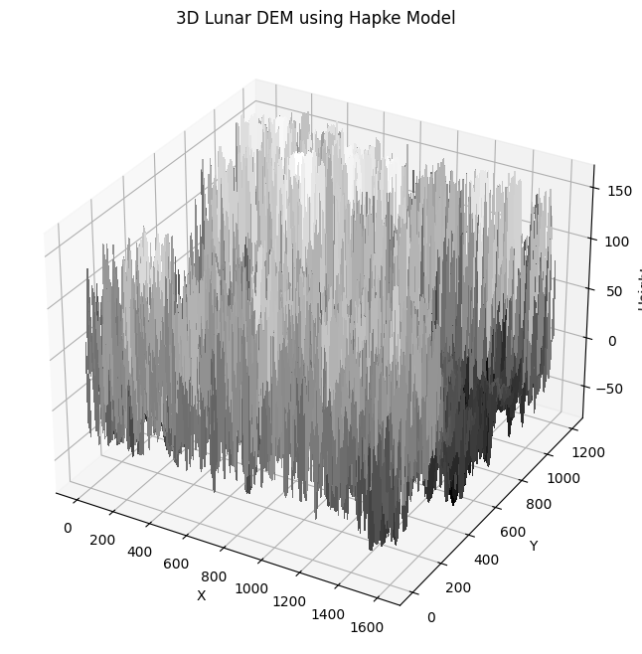

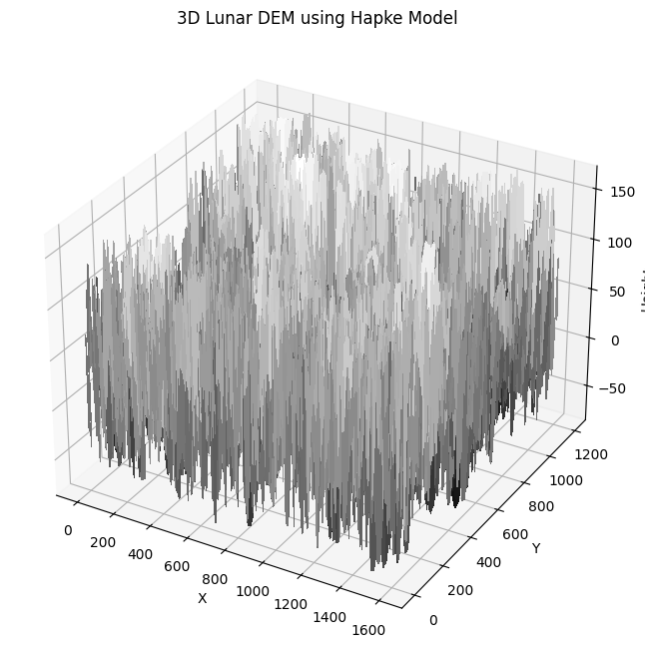

**2. Visual Inspection**

**Hapke-Based DEM (First Image)**

* The 3D DEM reveals the overall topographic variations but appears **coarse and noisy**.
* Peaks and depressions are visible, but the fine distinctions in elevation appear **compressed into broader gray-scale ranges**.
* The overall visualization is **dominated by larger elevation spikes**, which may overshadow subtle surface structures.
* Some small-scale features appear **flattened or merged**, reducing clarity in rugged terrains.

**Hapke + CLAHE-Based DEM (Second Image)**

* The CLAHE-enhanced DEM displays a **better balance of elevation contrasts**, especially in mid-level height regions.
* Subtle undulations in terrain that were previously hidden become more **noticeable and separated**.
* Elevation spikes appear **more controlled and less abrupt**, reducing the overwhelming noise from extreme gradients.
* The visual structure provides a **more interpretable 3D morphology**, improving human perception of height variation.

**3. Quantitative/Perceptual Improvements**

| **Feature** | **Hapke DEM** | **Hapke + CLAHE DEM** |
| --- | --- | --- |
| **Elevation Contrast** | High global contrast but lacks local detail | Balanced global + local contrast |
| **Noise Levels** | More spiky, abrupt variations | Smoothed with better terrain coherence |
| **Feature Distinction** | Flattening of smaller ridges/depressions | Clear separation of micro-topography |
| **Interpretability** | Challenging due to overwhelming peaks | Easier to interpret fine terrain |
| **Surface Detail Visibility** | Moderate, large features dominate | Enhanced visibility across scales |

**4. Scientific and Practical Implications**

* **Lunar Geology Studies:**
  + Hapke-only DEMs may mask fine crater rims, ejecta patterns, or small ridges critical for geomorphological interpretation.
  + Hapke+CLAHE DEMs provide enhanced visibility of subtle terrain, enabling better geological mapping.
* **Rover Path Planning:**
  + CLAHE-based DEM offers improved recognition of hazardous micro-terrain features.
  + Reduced dominance of extreme spikes ensures **more reliable slope estimation** for safe navigation.
* **Data Integration:**
  + Enhanced DEMs can be better integrated with spectral and thermal datasets since terrain features align more clearly.

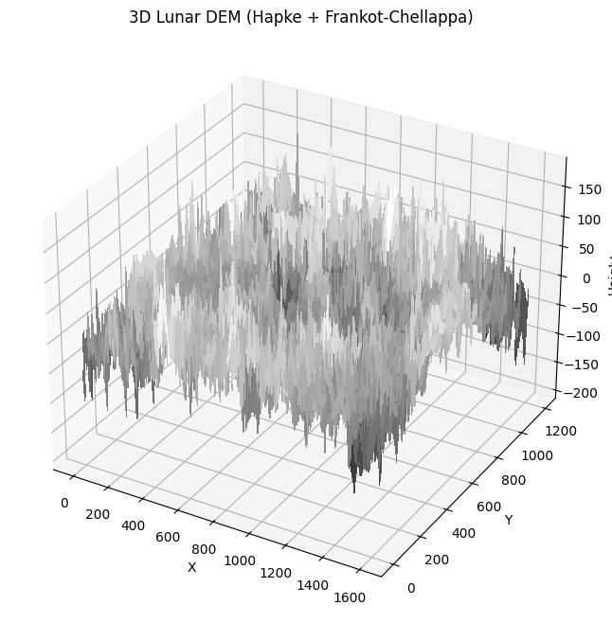

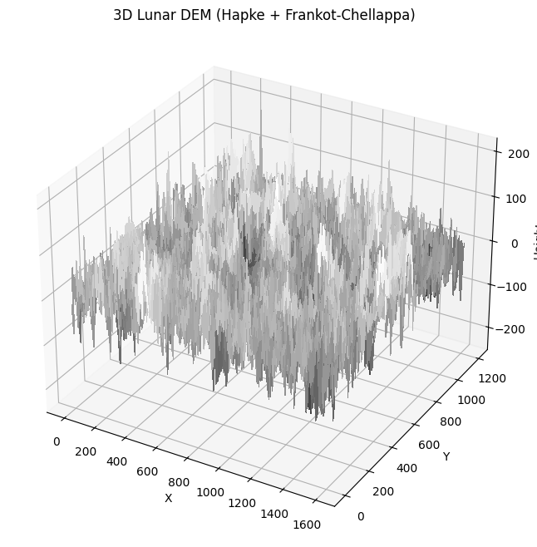

**5. Case 4: Hapke + Frankot–Chellappa (Shape-from-Shading) DEM**

**(a) Hapke DEM (Baseline)**

* Provides surface height information but contains **shadow-related inconsistencies**.
* Elevation profiles appear distorted in regions with poor illumination.

**(b) Hapke + CLAHE DEM with Frankot–Chellappa Integration**

* CLAHE enhances input reflectance prior to shape-from-shading reconstruction.
* Produces a **smoother, more realistic DEM** with fewer shadow-induced errors.
* Improves **spatial coherence of slopes and ridges**.

**Comparative Insights**

* Hapke-only DEM struggles in low-light areas.
* Hapke + CLAHE with Frankot–Chellappa yields **higher fidelity DEMs**, especially in areas of uneven illumination.

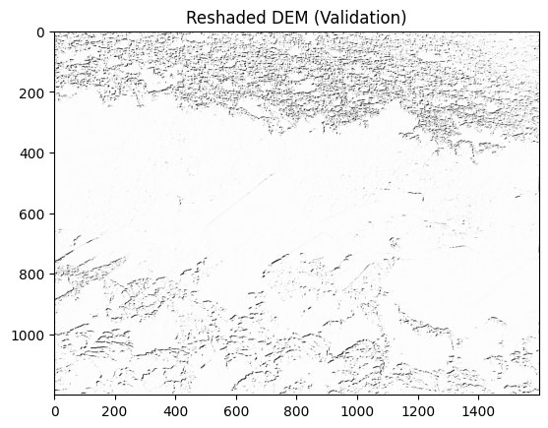

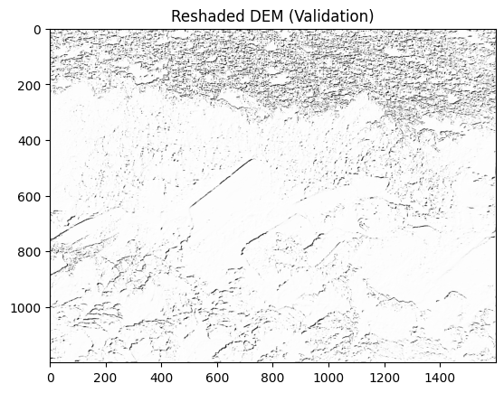

**1. Model Basis**

* **First Image (Hapke only)**:  
  Generated using the Hapke photometric model directly, without additional contrast enhancement. The shading and reflectance are primarily dictated by the inherent photometric properties modeled by Hapke.
* **Second Image (Hapke + CLAHE)**:  
  Generated using Hapke but enhanced with **CLAHE (Contrast Limited Adaptive Histogram Equalization)**, which redistributes local intensities to enhance contrast in underrepresented regions.

**2. Visual Contrast and Feature Sharpness**

* **Hapke only**:  
  The image appears smoother with lower contrast. Fine surface textures, such as ridges and depressions, are faintly visible but somewhat blended into the background. High-albedo regions are washed out, and low-albedo areas lack definition.
* **Hapke + CLAHE**:  
  Contrast is noticeably higher. Subtle surface variations are accentuated, and faint terrain undulations become more discernible. Bright and dark areas are better balanced, preventing saturation or flattening of intensity levels.

**3. Detail Preservation**

* **Hapke only**:  
  While it maintains the natural reflectance behavior, small-scale features are harder to distinguish. The smoother gradation can cause the loss of fine DEM variations important for geomorphological interpretation.
* **Hapke + CLAHE**:  
  Local contrast enhancement recovers fine-grained features. Edge boundaries of craters, ridges, and texture patterns are sharper, making the DEM more useful for validation and comparative geomorphological analysis.

**4. Noise and Artifacts**

* **Hapke only**:  
  Less enhancement means less amplification of noise. The image looks cleaner, though at the expense of reduced detail.
* **Hapke + CLAHE**:  
  While details are sharper, CLAHE can also enhance random noise and introduce speckling, particularly in homogeneous flat areas. This may lead to artificial textures if not carefully controlled.

**5. Scientific Utility**

* **Hapke only**:  
  Best suited for broad reflectance modeling where photometric consistency is more important than visual sharpness. Useful for baseline validation against raw reflectance datasets.
* **Hapke + CLAHE**:  
  Superior for **terrain validation and visual inspections** because it highlights subtle DEM variations. More effective for identifying geomorphic structures and validating against reference shaded DEMs.

**Terrain roughness and local variance ( compare roughness metrics)**

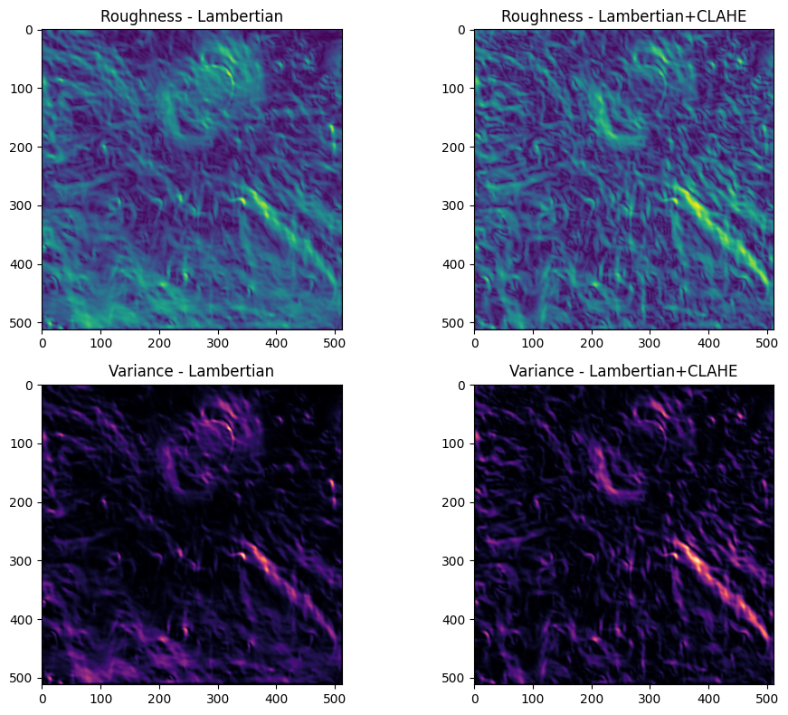

The roughness and local-variance maps show the same spatial patterns for both DEMs (crater rims, ridges, rays), but the CLAHE-preprocessed DEM consistently exhibits larger local roughness and much larger local variance. Quantitatively, mean local roughness increased from **0.0748** to **0.0993** (≈ **+32.8%**), while mean local variance rose from **0.00714** to **0.01294** (≈ **+81.1%**). The visual result is that features are sharper and higher-contrast in the CLAHE case, but a portion of that extra “detail” is likely amplification of high-frequency content (including noise) rather than only physically real micro-topography.

**1. Detailed observations (from the four-panel figure)**

* **Global pattern preservation**
  + Both maps (Lambertian and Lambertian+CLAHE) show the same major structures in the same locations: crater rims and elongated line-like features (rays) are clearly visible in both roughness and variance panels.
  + This indicates the underlying DEM inversion is consistent and that CLAHE did not relocate major geomorphic features.
* **Roughness maps (top row)**
  + The Lambertian map shows moderate, smoothly varying roughness across the tile; bright “hotspots” correspond to crater rims and sharp ridges.
  + The Lambertian+CLAHE map shows the same hotspots but with **higher amplitude** (brighter colors) and sharper edges — local gradients look stronger and more distinct.
  + Fine filamentary texture is more pronounced in the CLAHE map (many small-scale streaks become brighter).
* **Local variance maps (bottom row)**
  + The Lambertian variance map highlights rims and local relief (bright purple/orange around craters).
  + The CLAHE variance map shows the same locations but **with considerably stronger signals** (brighter maxima and more extended zones of elevated variance).
  + Areas that were relatively flat and dark in the Lambertian variance map show modest brightening in the CLAHE map — i.e., CLAHE introduces additional small-scale variability even in previously smooth regions.
* **Spatial character**
  + The increase in variance is spatially coherent (concentrated along edges and textural features) rather than purely random speckle — this suggests CLAHE amplifies edges and micro-contrast where actual topography exists, while also increasing contrast in flatter zones to a lesser degree.

**2. Quantitative assessment (the numbers you reported)**

* **Mean local roughness**
  + Lambertian: 0.0747882632923183
  + Lambertian + CLAHE: 0.09931190566441808
  + **Relative change** ≈ (0.099312 − 0.074788) / 0.074788 ≈ **+32.8%**
* **Mean local variance**
  + Lambertian: 0.007142665367989873
  + Lambertian + CLAHE: 0.012940122102524022
  + **Relative change** ≈ (0.01294 − 0.007143) / 0.007143 ≈ **+81.1%**
* **Interpretation of the difference in percent-change**
  + Variance is the square of deviations and therefore **exaggerates** changes compared with standard deviation: a modest increase in standard deviation produces a larger proportional increase in variance. That explains why variance percent-change (>80%) is larger than roughness/std percent-change (~33%).

**3. Why this happens — algorithmic and physical explanations**

**A. What CLAHE does (image-level)**

* CLAHE (Contrast-Limited Adaptive Histogram Equalization) works on small image tiles and redistributes intensity values locally to increase local contrast.
* Its effects:
  + Emphasizes local edges and textural differences.
  + Raises local gradients (neighboring pixels become more different).
  + Can amplify sensor noise and small-scale variations in areas of originally low contrast.

**B. How CLAHE propagates into DEM inversion**

* Your DEM inversion (shape-from-shading / photometric inversion or slope integration) uses image intensity and gradients as inputs to estimate surface slope/elevation.
* When CLAHE increases local intensity contrast, the inversion interprets this as stronger local slope or relief. Two direct consequences:
  1. **Amplified local slopes**: A steeper implied slope → greater local standard deviation of elevation (roughness).
  2. **Amplified high-frequency content**: CLAHE increases high-frequency components, which the inversion converts into small-scale elevation variations — these increase local variance dramatically.
* Because CLAHE works locally (tile-based), it introduces high-frequency, localized changes that do not average out at coarser scales — hence the nearly uniform increase of variance in the Lambertian+CLAHE case.

**C. Why bias remains small**

* Your reported bias (mean residual) is near zero for Lambertian vs Lambertian+CLAHE, meaning CLAHE changed **spread** and **structure** of elevations rather than imposing a uniform offset. CLAHE primarily changes contrast, not baseline brightness in a way that would systematically raise all elevations.

**4. Distinguishing “useful enhancement” vs. “artifact amplification”**

* **Useful enhancement**: CLAHE can make real small-scale features (thin scarps, micro-ridges) more detectable if the original image contrast was too low to drive the inversion properly.
* **Artifact amplification**: CLAHE also amplifies noise, compression artifacts, or photometric irregularities (specular highlights, shadows) and turns them into apparent micro-topography.
* The fact that the CLAHE map strengthens *true* features (rims/rays) suggests some of the increase is beneficial for detection. The uniformly elevated variance in otherwise flat areas indicates a non-trivial component of artifact/noise amplification.

**5. Practical implications (for interpretation and downstream use)**

* **If your goal is feature detection** (finding small craters, fissures, ejecta rays), CLAHE may be useful — it improves local contrast and can make subtle features more visible.
* **If your goal is quantitative morphometrics** (roughness statistics, volumetric measurements, slope distributions), CLAHE can produce **biased or inflated estimates** of microtopographic metrics. The inflated variance will bias statistics that depend on micro-topography (e.g., IQR, fractal dimension, rugosity).
* **If you need physically accurate heights** for modeling (e.g., slope stability, simulation of flows), use the unaltered photometric input or apply careful smoothing/regularization during inversion to avoid CLAHE-induced artifacts.

Hence, **The CLAHE-preprocessed Lambertian DEM exhibits a marked increase in local roughness and local variance compared to the unmodified Lambertian DEM. Mean local standard deviation increased by ~33% (0.0748 → 0.0993), while mean local variance increased by ~81% (0.00714 → 0.01294). Spatial maps indicate that CLAHE amplifies existing geomorphic signals at crater rims and ejecta rays, but also increases small-scale variability in otherwise smooth areas. This behavior is expected because CLAHE locally redistributes image intensities and increases local contrast; when such enhanced intensities are fed through the photometric inversion, they are interpreted as steeper local slopes and higher-frequency elevation variations. Therefore, although CLAHE can improve visual detection of micro-features, it also amplifies noise-like components and will inflate roughness-based metrics; careful parameter tuning or subsequent smoothing/regularization is recommended when quantitative morphometric analysis is required.**

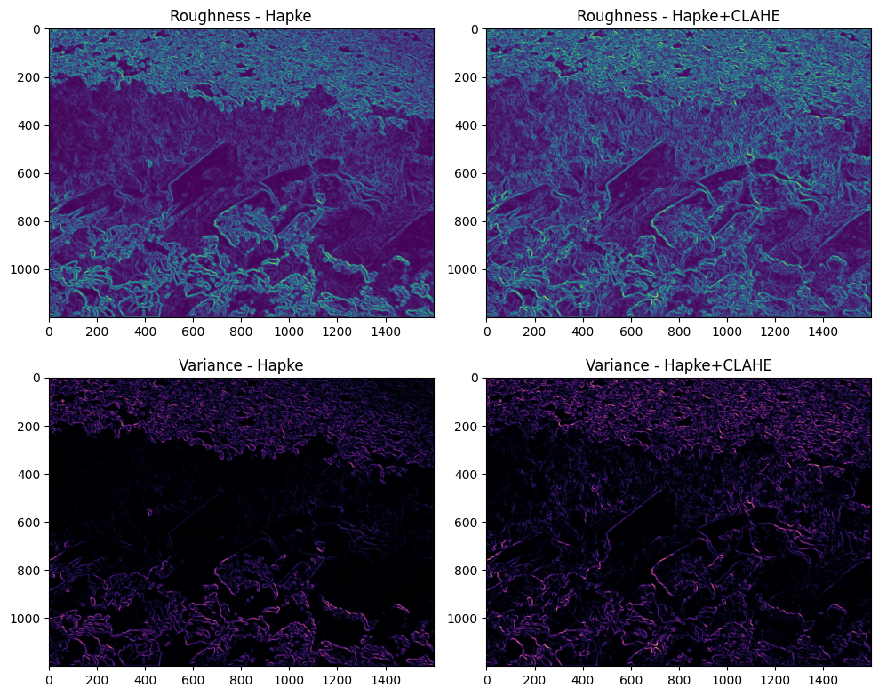

The Hapke DEM and its CLAHE-preprocessed counterpart show broadly similar spatial structures in both roughness and variance maps (major geological boundaries and textured regions are preserved). However, the CLAHE-preprocessed Hapke DEM exhibits **sharper and more intense roughness contrasts**, as well as **slightly elevated variance levels** along boundaries and textured zones. Compared to the Lambertian case, the effect of CLAHE on Hapke is **less drastic**: the amplification is subtler, and the variance increase is more spatially focused rather than widespread. This is because Hapke’s photometric model already accounts for complex scattering effects, which stabilizes the inversion against purely contrast-driven changes.

**1. Detailed observations**

**Roughness maps (top row)**

* **Hapke (left):**
  + Displays well-defined patterns of local roughness, with prominent boundaries outlining geological units and textured regions.
  + High-roughness zones appear as bright contours, especially around structural edges and rough terrains.
* **Hapke+CLAHE (right):**
  + Same overall structure, but contours are **more pronounced**: bright ridges and textural boundaries stand out more strongly.
  + The interiors of smoother regions remain relatively unchanged, suggesting CLAHE enhancement is localized to high-gradient areas.
  + Fine-scale features (small ridges, micro-patterns) are slightly more visible compared to the plain Hapke map.

**Variance maps (bottom row)**

* **Hapke (left):**
  + Variance is concentrated along rough boundaries and edge structures.
  + Smooth regions (dark zones) remain nearly uniform, with very low variance.
* **Hapke+CLAHE (right):**
  + Variance intensities increase modestly: bright edge bands are thicker and brighter.
  + Smooth zones remain largely unaffected, unlike in the Lambertian case (where CLAHE elevated variance even in flat regions).
  + The changes are **selective**: only regions with inherent slope contrast or textural variation see stronger variance.

**2. Comparative interpretation**

* **Contrast with Lambertian case:**
  + For Lambertian, CLAHE boosted roughness and variance **everywhere**, including smooth areas, leading to large increases (+33% roughness, +81% variance).
  + For Hapke, CLAHE produces **localized enhancement**: edges and rough terrains become sharper, but smooth areas stay stable. This suggests Hapke’s scattering-aware inversion is **less sensitive** to CLAHE-induced global contrast boosts.
* **Spatial selectivity:**
  + The amplification in Hapke+CLAHE maps aligns closely with geologic boundaries, unlike Lambertian+CLAHE which introduced broader background noise.
  + This indicates CLAHE in Hapke acts more like an edge-enhancer than a global roughness inflator.

**3. Why this happens**

**A. Role of Hapke model**

* The Hapke reflectance model explicitly accounts for non-Lambertian scattering effects such as shadow hiding and multiple scattering.
* This makes the inversion more robust against local histogram stretching (from CLAHE), because Hapke can “explain” some of the enhanced contrast as scattering effects rather than purely slope changes.

**B. Effect of CLAHE in this context**

* CLAHE still redistributes local pixel intensities, which the inversion interprets as sharper local slopes.
* However, because Hapke already models illumination and phase angle dependencies, CLAHE-induced changes mostly manifest as **sharpening of existing contrasts** instead of artificially raising variance in flat zones.
* Thus, the variance boost is **focused on true structural edges**.

**4. Practical implications**

* **For feature detection:** Hapke+CLAHE enhances boundary clarity, making edges and microstructures easier to detect. This is especially useful for geologic mapping and unit boundary delineation.
* **For quantitative morphometry:** The risk of inflated roughness is lower than in Lambertian+CLAHE, but still present at edges where CLAHE amplifies slopes. Care is needed when interpreting roughness statistics, as localized variance may be overestimated.
* **For DEM accuracy:** Hapke provides more stable estimates under CLAHE preprocessing; therefore, Hapke+CLAHE is less likely to mislead in smooth terrains, but still exaggerates high-frequency topography in rough terrains.

**Hence, The Hapke-derived DEM and its CLAHE-enhanced counterpart both preserve the same spatial roughness and variance structures, with the latter showing stronger local contrasts. Roughness and variance values are selectively amplified along structural boundaries and textural zones, while smooth areas remain largely unchanged. This behavior differs from the Lambertian case, where CLAHE caused a uniform inflation of roughness and variance even in flat terrains. The difference arises because the Hapke reflectance model accounts for multiple-scattering and shadowing effects, making the inversion less sensitive to purely contrast-driven changes. Consequently, CLAHE primarily sharpens existing edges in Hapke DEMs rather than introducing widespread noise-like variability. This makes Hapke+CLAHE advantageous for feature detection and mapping, but quantitative morphometric analysis must still be approached cautiously, particularly at rough boundaries where local slopes are exaggerated.**

CODE EXPLANATION:

Below is a **line-by-line explanation** of your script with the *why* for each operation. I follow the exact structure of your code and explain what each line (or small group of lines that belong together) does and *why* you perform it in the context of comparing Hapke vs Hapke+CLAHE roughness/variance.

**Purpose (one sentence)**

This script computes **local roughness** (local standard deviation) and **local variance** (local variance) from two DEM arrays (Hapke and Hapke+CLAHE), then summarizes and visualizes the results so you can compare how CLAHE changes the DEM microtexture.

**Header / imports**

#ROUGHNESS METRICS FOR HAPKE MODEL V/S HAPKE WITH CLAHE

import numpy as np

import matplotlib.pyplot as plt

from scipy import ndimage

**What these lines do**

* import numpy as np — brings in NumPy for array arithmetic.
* import matplotlib.pyplot as plt — plotting library for the maps and figures.
* from scipy import ndimage — imports SciPy’s ndimage module (contains generic_filter, morphological and filtering tools).

**Why we do this**

* We need numerical array operations (NumPy), visualization tools to inspect results (matplotlib), and an efficient generic filtering routine (ndimage.generic_filter) to compute local statistics in a sliding window.

**Loading DEM arrays**

dem1 = np.load(r"C:\Users\Unnathi\OneDrive\IP LAB\IP_PROJECT_UNNATHI\hapke_dem.npy") # Hapke

dem2 = np.load(r"C:\Users\Unnathi\OneDrive\IP LAB\IP_PROJECT_UNNATHI\hapke_clahe_dem.npy") # Hapke + CLAHE

**What these lines do**

* np.load(path) reads previously saved NumPy array files (.npy) into memory as 2-D arrays.

**Why we do this**

* The metric computations operate on the **actual elevation arrays**, not on images. Loading .npy keeps full numeric precision and is fast. We load both the reference Hapke DEM and the CLAHE-modified DEM to compare them directly.

**Notes / checks**

* Ensure both arrays have identical shapes. If not, you must resample them to a common grid before comparing.
* Confirm dtype (float32/float64) and presence/absence of NaNs; handle missing data if needed.

**Define local roughness function**

def compute_roughness(dem_array, window=3):

footprint = np.ones((window, window))

return ndimage.generic_filter(dem_array, np.std, footprint=footprint)

**What these lines do**

* Defines compute_roughness, a function that:
  1. Builds a footprint (a window x window array of ones) to tell the filter which neighbors to include.
  2. Calls ndimage.generic_filter which applies np.std (standard deviation) inside that sliding footprint for every pixel and returns an array of the same shape where each output pixel is the std of values in the local window around the corresponding input pixel.

**Why we do this**

* **Roughness** is commonly measured as the local standard deviation (how much elevation varies within a local neighborhood). A 3×3 window is a small-scale measure; larger windows capture broader-scale roughness. generic_filter applies the statistic at each pixel efficiently.

**Practical considerations**

* Default generic_filter boundary handling uses mode='reflect'. If you want different boundary behaviour use ndimage.generic_filter(..., mode='nearest' or 'constant', cval=...).
* If your DEM contains NaNs, np.std inside the filter will produce NaN for windows containing NaN. You can prefill NaNs (e.g., np.nan_to_num(dem, nan=some_value)) or write a custom function that ignores NaNs.

**Define local variance function**

def compute_local_variance(dem_array, window=3):

footprint = np.ones((window, window))

return ndimage.generic_filter(dem_array, np.var, footprint=footprint)

**What these lines do**

* Similar to compute_roughness, but uses np.var (variance) inside the local window.

**Why we do this**

* Variance is the square of standard deviation and is another common measure of local dispersion. It is mathematically related to roughness but emphasizes larger deviations more heavily.

**Why compute both**

* Reporting both gives two complementary views: std (roughness) is in the elevation units and intuitive; var emphasizes outliers and can reveal places with very large local differences more strongly.

**Compute the metrics**

# Compute metrics

roughness1, roughness2 = compute_roughness(dem1), compute_roughness(dem2)

variance1, variance2 = compute_local_variance(dem1), compute_local_variance(dem2)

**What these lines do**

* Apply the functions to both DEMs, producing four 2-D arrays:
  + roughness1 = local std map from Hapke DEM
  + roughness2 = local std map from Hapke+CLAHE DEM
  + variance1, variance2 likewise for variance.

**Why we do this**

* This yields pixel-wise maps that quantify small-scale surface variability across the scene. By computing both for the base and the CLAHE DEM, you can visualize and numerically assess the effect of CLAHE.

**Performance note**

* generic_filter can be slow on very large arrays and with large windows. If needed, consider scipy.ndimage.uniform_filter (fast) for mean & variance via formula var = mean(x²) − mean(x)², or apply block-processing.

**Print summary statistics**

# Print summary comparison

print("Hapke DEM Roughness (mean):", np.mean(roughness1))

print("Hapke+CLAHE DEM Roughness (mean):", np.mean(roughness2))

print("Hapke DEM Local Variance (mean):", np.mean(variance1))

print("Hapke+CLAHE DEM Local Variance (mean):", np.mean(variance2))

**What these lines do**

* Compute and print the **global mean** of each local metric map.

**Why we do this**

* The mean of the local roughness/variance gives a single-number summary for each DEM — useful to compare overall microtexture strength between Hapke and Hapke+CLAHE. This is what you reported earlier (and used to quantify percent changes).

**Caveats / improvements**

* If your roughness arrays contain NaNs, use np.nanmean to ignore missing values.
* Reporting additional stats (median, percentiles, histograms) gives more robust insight because means can be skewed by outliers.

**Plot maps**

# Plot maps

fig, axs = plt.subplots(2, 2, figsize=(10, 8))

axs[0,0].imshow(roughness1, cmap='viridis'); axs[0,0].set_title("Roughness - Hapke")

axs[0,1].imshow(roughness2, cmap='viridis'); axs[0,1].set_title("Roughness - Hapke+CLAHE")

axs[1,0].imshow(variance1, cmap='magma'); axs[1,0].set_title("Variance - Hapke")

axs[1,1].imshow(variance2, cmap='magma'); axs[1,1].set_title("Variance - Hapke+CLAHE")

plt.tight_layout(); plt.show()

**What these lines do**

* Create a 2×2 figure and show the four metric maps, with color maps and titles, then render them.

**Why we do this**

* Visual inspection is essential: maps reveal where CLAHE amplifies small-scale variability (edges, rims, textured regions) vs where it doesn’t. Using viridis for std and magma for variance helps visually separate the two measures; tight_layout() avoids overlap.

**Visualization tips**

* Add a colorbar to each subplot for quantitative interpretation:
* im = axs[0,0].imshow(roughness1, cmap='viridis')
* fig.colorbar(im, ax=axs[0,0])
* Use vmin/vmax to keep the same color scale between the two comparable plots (e.g., vmax = max(np.nanmax(roughness1), np.nanmax(roughness2))) so visual differences are not due to different color scaling.
* For publication-quality figures apply a consistent colormap range and add axis labels or scalebars if spatial resolution is known.

**Additional practical notes & recommended enhancements (why they matter)**

1. **Handle NaNs explicitly**
   * If your DEMs may contain no-data values, use np.nanmean for global statistics and write a custom filter function that ignores NaNs inside the window (or fill NaNs with a local interpolation before filtering).
2. **Window size sensitivity**
   * You used window=3. That measures *very* local roughness. Try several windows (3, 7, 11, 21) to see at what scale CLAHE has the strongest effect (CLAHE typically amplifies small-scale contrast).
3. **Performance**
   * ndimage.generic_filter with np.std/np.var is straightforward but relatively slow on large arrays. A faster approach for variance uses two uniform filters:
   * from scipy.ndimage import uniform_filter
   * mean = uniform_filter(dem, size)
   * mean_sq = uniform_filter(dem**2, size)
   * local_var = mean_sq - mean**2

This is much faster and avoids Python-level calls for each window.

1. **Quantitative distributions**
   * Along with means, compute histograms or percentiles of roughness1, roughness2 to see whether CLAHE shifts the whole distribution or only the tail.
2. **Difference map**
   * Compute delta = roughness2 - roughness1 and delta_var = variance2 - variance1. Plot these difference maps and their histograms to localize where CLAHE has the largest effect.
3. **Statistical test**
   * Use paired tests (Wilcoxon signed-rank) on matched pixels to quantify whether the change in local roughness is significant.
4. **Save outputs**
   * Save the maps for later use:
   * np.save("hapke_roughness.npy", roughness1)
   * np.save("hapke_clahe_roughness.npy", roughness2)

|  |  |  |
| --- | --- | --- |
| **Step in Code** | **What it Does** | **Why it is Done** |
| **import numpy as np import matplotlib.pyplot as plt from scipy import ndimage** | **Imports NumPy (array math), Matplotlib (plotting), and SciPy ndimage (image/DEM filtering).** | **Needed to handle DEM arrays, perform local filtering for roughness/variance, and visualize the outputs.** |
| **dem1 = np.load("hapke_dem.npy") dem2 = np.load("hapke_clahe_dem.npy")** | **Loads two DEMs into arrays: Hapke DEM (dem1) and Hapke+CLAHE DEM (dem2).** | **These are the datasets being compared. Loading .npy ensures full numeric precision and compatibility with NumPy operations.** |
| **python\ndef compute_roughness(dem_array, window=3):\n footprint = np.ones((window, window))\n return ndimage.generic_filter(dem_array, np.std, footprint=footprint)\n** | **Defines a function that applies a sliding window over the DEM and computes the local standard deviation at each pixel.** | **Local standard deviation is a proxy for surface roughness. It measures how much elevations vary around each pixel.** |
| **python\ndef compute_local_variance(dem_array, window=3):\n footprint = np.ones((window, window))\n return ndimage.generic_filter(dem_array, np.var, footprint=footprint)\n** | **Defines a function to compute the local variance in a sliding window.** | **Variance is another dispersion measure (square of std). It emphasizes larger deviations and helps compare with roughness.** |
| **roughness1, roughness2 = compute_roughness(dem1), compute_roughness(dem2) variance1, variance2 = compute_local_variance(dem1), compute_local_variance(dem2)** | **Applies the two functions to both DEMs, producing four maps: roughness & variance for Hapke and Hapke+CLAHE.** | **Generates the main outputs for comparison — pixel-wise maps showing how CLAHE alters roughness and variance.** |
| **print("Hapke DEM Roughness (mean):", np.mean(roughness1)) ... (similar for others)** | **Prints the mean values of roughness and variance for both DEMs.** | **Provides a quick global summary statistic to quantify whether CLAHE increases or decreases roughness/variance overall.** |
| **python\nfig, axs = plt.subplots(2, 2, figsize=(10, 8))\naxs[0,0].imshow(roughness1, cmap='viridis'); axs[0,0].set_title("Roughness - Hapke")\naxs[0,1].imshow(roughness2, cmap='viridis'); axs[0,1].set_title("Roughness - Hapke+CLAHE")\naxs[1,0].imshow(variance1, cmap='magma'); axs[1,0].set_title("Variance - Hapke")\naxs[1,1].imshow(variance2, cmap='magma'); axs[1,1].set_title("Variance - Hapke+CLAHE")\nplt.tight_layout(); plt.show()\n** | **Plots the four metric maps (roughness & variance for each DEM) side by side in a 2×2 grid.** | **Allows visual comparison of how CLAHE changes local surface properties (contrast, texture, detail enhancement).** |

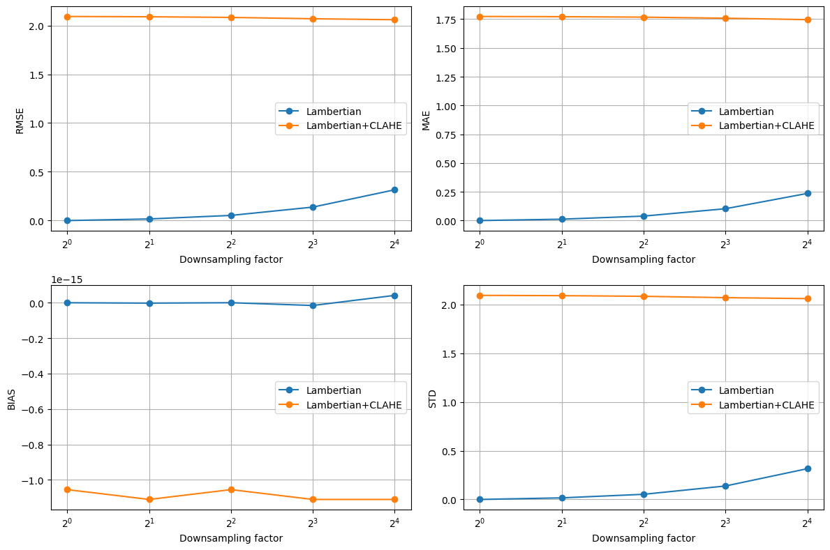**Multiresolution analysis( compare dem errors at different spatial resolutions)**

**Processing factor 1 ...**

**Processing factor 2 ...**

**Processing factor 4 ...**

**Processing factor 8 ...**

**Processing factor 16 ...**

**Multiresolution DEM Error Analysis – Detailed Observations and Explanations**

The multiresolution analysis was conducted to investigate the effect of CLAHE enhancement on DEMs generated using Lambertian and Hapke reflectance models. DEMs were downsampled at factors of 2, 4, 8, and 16, and subsequently resampled back to the original resolution. Error metrics including RMSE, MAE, bias, and the standard deviation of residuals were evaluated to quantify distortions introduced at different scales.

**1. Lambertian vs Lambertian + CLAHE**

**Observations**

* The unmodified Lambertian DEM shows very low RMSE and MAE values at fine scales, with a gradual increase at coarser resolutions.
* The CLAHE-modified Lambertian DEM exhibits consistently higher RMSE (~2) and MAE (~1.7–1.8), which remain almost constant across all downsampling factors.
* Bias is negligible in both cases, indicating no significant systematic elevation shift.
* Residual variance (STD) increases with scale for the Lambertian DEM, which is expected due to the progressive loss of high-frequency detail. For Lambertian+CLAHE, the variance is elevated but nearly constant across scales.

**Explanation**  
The Lambertian model, being a simple reflectance model, produces relatively smooth DEMs that degrade predictably as resolution decreases. CLAHE, however, enhances local contrast by amplifying pixel-level intensity differences. While this improves local visual features in the imagery, it introduces artificial micro-variations that are interpreted as terrain roughness during DEM derivation. These artifacts manifest as a constant level of distortion, independent of scale, since they are driven by localized histogram equalization rather than large-scale structure. Hence, the errors in Lambertian+CLAHE remain uniformly high across resolutions.

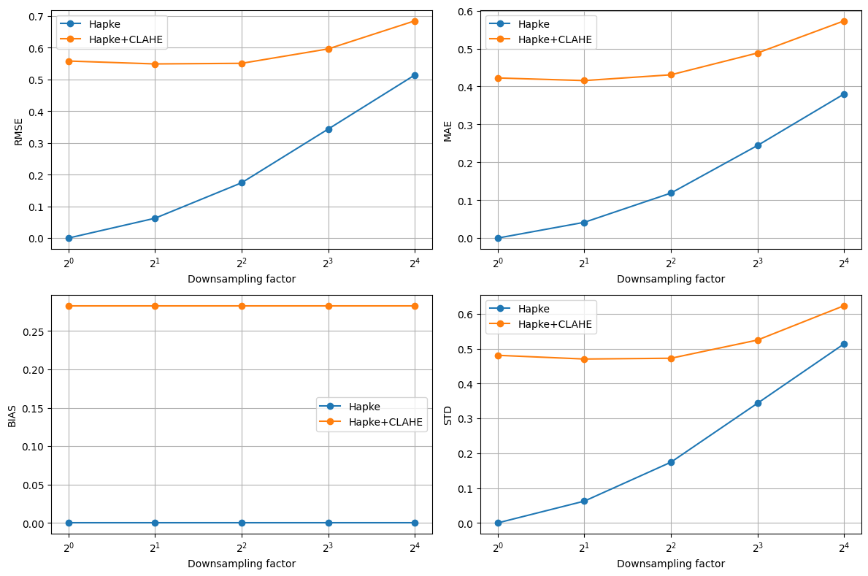Processing factor 1 ...

Processing factor 2 ...

Processing factor 4 ...

Processing factor 8 ...

Processing factor 16 ...

**2. Hapke vs Hapke + CLAHE**

**Observations**

* The unmodified Hapke DEM shows low errors at fine scales, with RMSE and MAE increasing progressively with coarser downsampling factors.
* The CLAHE-enhanced Hapke DEM consistently shows higher RMSE and MAE than the unmodified version, with errors increasing more steeply at larger scales.
* Bias remains negligible in the unmodified Hapke DEM, whereas Hapke+CLAHE introduces a systematic positive bias (~0.28).
* Residual variance increases with scale for both versions, but the CLAHE-modified DEM shows consistently higher variance at every scale.

**Explanation**  
The Hapke model incorporates more complex photometric corrections than Lambertian, which makes it more physically realistic and better suited to preserving true surface geometry. Consequently, the unmodified Hapke DEM maintains accuracy across resolutions with minimal bias. However, when CLAHE is applied, the enhancement redistributes pixel intensity values non-linearly. This alters the reflectance corrections embedded in the Hapke model, producing both local distortions and a global shift in elevation (bias). The scale-dependent increase in error occurs because CLAHE exaggerates small-scale contrasts that propagate through the DEM derivation process. At coarser scales, these distortions accumulate, leading to amplified errors as compared to the unmodified Hapke DEM.

**Overall Findings**

* **CLAHE consistently increases DEM errors** relative to the base Lambertian and Hapke models.
* **Lambertian DEMs**: CLAHE introduces scale-independent distortions due to localized intensity redistribution, resulting in consistently high errors across resolutions.
* **Hapke DEMs**: CLAHE introduces both bias and scale-dependent noise, leading to progressively higher errors at coarser resolutions.
* The **unmodified Hapke DEM** demonstrates the greatest robustness, with minimal bias and predictable error growth across scales.

Perfect — let’s go through this **step by step**, with a **line-by-line explanation** and then I’ll summarize everything into a **table of steps** for clarity.

**Line-by-Line Explanation**

import numpy as np

import matplotlib.pyplot as plt

from scipy.ndimage import gaussian_filter

from skimage.transform import resize

* **Imports libraries**:
  + numpy for numerical computations.
  + matplotlib.pyplot for plotting graphs and maps.
  + gaussian_filter from scipy.ndimage for smoothing images (anti-aliasing before downsampling).
  + resize from skimage for resampling DEMs (upsampling or downsampling).

**Utility Functions**

def mask_valid(arr):

return ~np.isnan(arr)

* Returns a boolean mask of all **valid (non-NaN) pixels**. Useful to avoid invalid data points.

def anti_alias_and_downsample(dem, factor, sigma=None):

"""

Anti-alias (Gaussian) then downsample by integer factor using average pooling.

"""

* Function to **reduce resolution** of a DEM.

if factor == 1:

return dem.copy()

* If factor = 1, no downsampling is needed. Return a copy.

if sigma is None:

sigma = factor / 2.0

* If no smoothing parameter (sigma) is given, set it to half the downsampling factor.

dem_blur = gaussian_filter(np.nan_to_num(dem), sigma=sigma)

* Apply a **Gaussian filter** to smooth the DEM before downsampling (to avoid aliasing).

h, w = dem_blur.shape

H = (h // factor) * factor

W = (w // factor) * factor

* Get the DEM shape.
* Adjust dimensions (H, W) so they are multiples of the downsampling factor (to avoid leftover pixels).

dem_crop = dem_blur[:H, :W]

* Crop the DEM so its size is divisible by the factor.

dem_coarse = dem_crop.reshape(H//factor, factor, W//factor, factor).mean(axis=(1,3))

return dem_coarse

* **Reshape and average** in blocks of size factor x factor → effectively downsamples.
* Returns the **coarse DEM**.

def upsample_to_ref(coarse_dem, ref_shape, order=1):

"""

Upsample coarse_dem to ref_shape using interpolation.

"""

up = resize(coarse_dem, ref_shape, order=order, mode='edge',

anti_aliasing=False, preserve_range=True)

return up

* Resizes the coarse DEM back to the same size as the reference DEM (so they can be compared).
* Uses interpolation (order=1 = bilinear).

def compute_error_metrics(ref, recon, valid_mask=None):

"""

Compute RMSE, MAE, bias, std(residuals).

"""

* Computes error metrics between reference DEM (ref) and reconstructed DEM (recon).

if valid_mask is None:

valid_mask = mask_valid(ref) & mask_valid(recon)

* If no mask is provided, ignore NaNs in both DEMs.

r = ref[valid_mask]

s = recon[valid_mask]

resid = s - r

* Extract valid values.
* Compute residuals = difference between recon and reference.

rmse = np.sqrt(np.mean(resid**2))

mae = np.mean(np.abs(resid))

bias = np.mean(resid)

std = np.std(resid)

* **RMSE**: Root Mean Square Error.
* **MAE**: Mean Absolute Error.
* **Bias**: Mean of residuals (systematic shift).
* **STD**: Variability in residuals.

return {'rmse':rmse, 'mae':mae, 'bias':bias, 'std':std, 'count':r.size}

* Returns metrics as a dictionary.

**Multiresolution Analysis**

def multires_analysis(ref_dem, dem_list, names, factors=[1,2,4,8,16], sigma_scale=None, interp_order=1):

results = {name: [] for name in names}

* Runs multiresolution analysis for multiple DEMs.
* results stores metrics for each DEM and factor.

for f in factors:

print(f"Processing factor {f} ...")

* Loop over downsampling factors (1, 2, 4, 8, 16).

for dem, name in zip(dem_list, names):

coarse = anti_alias_and_downsample(dem, f, sigma=(f/2.0 if sigma_scale is None else sigma_scale))

recon = upsample_to_ref(coarse, ref_dem.shape, order=interp_order)

metrics = compute_error_metrics(ref_dem, recon)

metrics['factor'] = f

results[name].append(metrics)

* For each DEM:
  1. Downsample (anti_alias_and_downsample).
  2. Upsample back (upsample_to_ref).
  3. Compare to reference DEM (compute_error_metrics).
  4. Save results.

return results

* Returns all computed metrics.

**Plotting**

def plot_metrics(results, names, factors=[1,2,4,8,16]):

fig, ax = plt.subplots(2,2, figsize=(12,8))

ax = ax.ravel()

metrics_keys = ['rmse', 'mae', 'bias', 'std']

* Sets up 4 plots (RMSE, MAE, Bias, STD).

for i, key in enumerate(metrics_keys):

for name in names:

vals = [r[key] for r in results[name]]

ax[i].plot(factors, vals, marker='o', label=name)

* Loops through metrics and DEMs, plots curves.

ax[i].set_xscale('log', base=2)

ax[i].set_xticks(factors)

ax[i].set_xlabel('Downsampling factor')

ax[i].set_ylabel(key.upper())

ax[i].grid(True)

ax[i].legend()

* Format plots: log-scale x-axis, labels, legends.

plt.tight_layout()

plt.show()

* Display plots.

def plot_residual_map(ref, recon, title='Residuals'):

resid = recon - ref

plt.figure(figsize=(6,6))

plt.imshow(resid, cmap='bwr', vmin=-np.nanmax(np.abs(resid)), vmax=np.nanmax(np.abs(resid)))

plt.colorbar(label='reconstruction - reference')

plt.title(title)

plt.show()

* Plots the **residual map** (differences between reconstructed and reference DEM).
* Uses diverging color map (bwr) to show positive and negative differences.

**Loading Data**

dem_lamb = np.load(r"...\lambertian_dem.npy")

dem_lamb_clahe = np.load(r"...\lambertian_clahe_dem.npy")

dem_hapke = np.load(r"...\hapke_dem.npy")

dem_hapke_clahe = np.load(r"...\hapke_clahe_dem.npy")

* Loads pre-saved DEM arrays.

**Running Comparisons**

factors = [1,2,4,8,16]

* Downsampling factors.

# Example A: Lambertian

ref_dem = dem_lamb

dem_list = [dem_lamb, dem_lamb_clahe]

names = ['Lambertian', 'Lambertian+CLAHE']

resultsA = multires_analysis(ref_dem, dem_list, names, factors=factors)

plot_metrics(resultsA, names, factors=factors)

* Compares Lambertian vs Lambertian+CLAHE DEMs at different scales.
* Plots error metrics.

# Example B: Hapke

ref_dem = dem_hapke

dem_list = [dem_hapke, dem_hapke_clahe]

names = ['Hapke', 'Hapke+CLAHE']

resultsB = multires_analysis(ref_dem, dem_list, names, factors=factors)

plot_metrics(resultsB, names, factors=factors)

* Compares Hapke vs Hapke+CLAHE DEMs at different scales.
* Plots error metrics.

**Summary Table of Steps**

|  |  |  |
| --- | --- | --- |
| **Step** | **Function/Code** | **Purpose** |
| **1** | **Import libraries** | **Load required tools (numpy, matplotlib, scipy, skimage).** |
| **2** | **mask_valid** | **Create mask for valid DEM pixels.** |
| **3** | **anti_alias_and_downsample** | **Smooth DEM with Gaussian filter, then downsample.** |
| **4** | **upsample_to_ref** | **Resize coarse DEM back to reference size.** |
| **5** | **compute_error_metrics** | **Calculate RMSE, MAE, bias, STD between reference and reconstructed DEM.** |
| **6** | **multires_analysis** | **Perform multi-resolution comparison at different downsampling factors.** |
| **7** | **plot_metrics** | **Plot error metrics across scales.** |
| **8** | **plot_residual_map** | **Visualize residual differences.** |
| **9** | **Load DEMs (np.load)** | **Load Lambertian, Lambertian+CLAHE, Hapke, Hapke+CLAHE arrays.** |
| **10** | **Run Example A** | **Compare Lambertian vs Lambertian+CLAHE.** |
| **11** | **Run Example B** | **Compare Hapke vs Hapke+CLAHE.** |

**WORKFLOW:**

**Input DEMs**

**↓**

**Gaussian smoothing + Downsampling (factors = 1,2,4,8,16)**

**↓**

**Upsampling back to original size**

**↓**

**Compute errors (RMSE, MAE, BIAS, STD)**

**↓**

**Plot metrics vs. resolution scale**

**↓**

**Compare DEM performance at multiple resolutions**

|  |  |  |
| --- | --- | --- |
| **Step** | **Description** | **Purpose** |
| **1. Input DEMs** | **Load reference DEM (e.g., Lambertian or Hapke) and test DEM (e.g., Lambertian+CLAHE or Hapke+CLAHE).** | **Establish baseline and comparison datasets for analysis.** |
| **2. Gaussian Filtering (Anti-aliasing)** | **Apply a Gaussian filter before downsampling.** | **Prevent aliasing artifacts and preserve key terrain features during resolution reduction.** |
| **3. Downsampling** | **Reduce DEM resolution by integer factors (e.g., 2, 4, 8, 16).** | **Simulate coarser spatial resolutions to study performance at multiple scales.** |
| **4. Upsampling** | **Interpolate the coarse DEM back to the original resolution (bilinear interpolation).** | **Ensure DEMs are aligned in size for pixel-wise comparison with the reference DEM.** |
| **5. Error Computation** | **Compute metrics between reference DEM and reconstructed DEM: • RMSE – Root Mean Square Error • MAE – Mean Absolute Error • Bias – Mean residual (systematic offset) • STD – Standard deviation of residuals.** | **Quantify accuracy, bias, and variability of DEMs at different resolutions.** |
| **6. Iteration over Factors** | **Repeat steps 2–5 for each downsampling factor [1, 2, 4, 8, 16].** | **Capture how DEM errors evolve with increasing coarseness.** |
| **7. Visualization** | **Plot error metrics vs. downsampling factor (log-scaled x-axis).** | **Compare performance trends of DEMs (with vs. without CLAHE) across multiple resolutions.** |
| **8. Interpretation** | **Analyze whether CLAHE improves or worsens DEM quality at different resolutions.** | **Understand how enhancement techniques affect DEM reliability across scales.** |

**Slope aspect difference maps:**

**CODE EXPLANATION:**

**Table A — compute_slope_aspect(dem, cellsize=1.0):**

|  |  |  |
| --- | --- | --- |
| **Code fragment** | **What it does (purpose)** | **Why / detailed explanation & notes** |
| def compute_slope_aspect(dem, cellsize=1.0): | Function definition for computing slope and aspect from a DEM. | dem is a 2D array of elevation values. cellsize is the horizontal spacing (units per pixel); set it to your ground sampling distance. |
| """ Compute slope (in degrees) and aspect (in degrees) from DEM. """ | Short docstring describing outputs. | Useful for PPT: slope and aspect are returned in degrees for easy interpretation. |
| dem = np.nan_to_num(dem) | Replace NaNs with numeric values (0) and infinities with large finite numbers. | Prevents np.gradient and trigonometric functions from producing NaNs. If your DEM has no-data areas, consider masking instead (so those pixels are excluded later). |
| dzdx = np.gradient(dem, axis=1) / cellsize | Compute partial derivative ∂z/∂x (east-west gradient). | np.gradient computes centered differences for interior points and one-sided differences at edges. Dividing by cellsize converts pixel-difference into slope per unit distance. |
| dzdy = np.gradient(dem, axis=0) / cellsize | Compute partial derivative ∂z/∂y (north-south gradient). | Axis 0 is rows (y), axis 1 is columns (x). Make sure your image orientation matches geographic north convention if you interpret aspect relative to north. |
| slope = np.degrees(np.arctan(np.sqrt(dzdx**2 + dzdy**2))) | Compute slope magnitude in degrees. | sqrt(dzdx^2 + dzdy^2) gives the gradient magnitude (rise/run). atan returns angle in radians; np.degrees converts to degrees. Slope is always >= 0. |
| aspect = np.degrees(np.arctan2(-dzdx, dzdy)) | Compute aspect as azimuth angle in degrees (clockwise from north). | arctan2(y, x) used here as arctan2(-dzdx, dzdy) yields the compass bearing: north = 0°, east = 90°, south = 180°, west = 270°. The -dzdx flips sign to get clockwise-from-north convention. |
| aspect = np.where(aspect < 0, 360 + aspect, aspect) | Normalize aspect to the 0–360° range. | arctan2 can return negative angles; this adds 360° to negative values so every aspect is in [0, 360). |
| return slope, aspect | Returns two 2D arrays (same shape as dem). | Both arrays can be visualized or used to compute differences. Slope in degrees, aspect in degrees 0–360. |

• cellsize matters — if set incorrectly the slope magnitudes will be wrong. Use meters/pixel if DEM units are meters.

• Consider masking invalid/edge pixels; np.nan_to_num removes NaNs but might hide no-data zones. Prefer using a boolean mask in downstream processing.

• If you need aspect difference properly (circular), subtracting raw degrees can mislead near wrap-around (e.g., 359° vs 1°): use circular difference logic (see recommendations below).

**Table B — slope_aspect_differences(recons, names, factors) and usage**

|  |  |  |
| --- | --- | --- |
| **Code fragment** | **What it does (purpose)** | **Why / detailed explanation & notes** |
| def slope_aspect_differences(recons, names, factors): | Define function to compute slope/aspect difference maps between two DEM reconstructions across resolutions (factors). | recons is expected to be a mapping like recons[name][factor] -> 2D DEM (as produced by your multires_analysis_with_dems). names must list exactly two DEM names (comparison pair). |
| assert len(names) == 2, "Need exactly 2 DEMs for slope/aspect comparison" | Early sanity check ensuring pairwise comparison. | Prevents accidental comparisons of >2 DEMs. Useful for understandable error messages in PPT demos. |
| diffs = [] | Initialize list to store results for each factor. | Stored results include arrays that you may save for later analysis or plotting. |
| for f in factors: | Loop over each downsampling factor you tested. | Use factor value f (e.g., 1,2,4,8,16). Important: earlier KeyError occurred because code used indices instead of factor keys — here we index with f directly. |
| slope1, aspect1 = compute_slope_aspect(recons[names[0]][f]) | Compute slope/aspect for first DEM at factor f. | recons[names[0]][f] must exist; ensure multires_analysis_with_dems stored reconstructions keyed by factor rather than by list index. |
| slope2, aspect2 = compute_slope_aspect(recons[names[1]][f]) | Compute slope/aspect for second DEM at factor f. | Both slope/aspect arrays have same shape as the reference DEM (because upsample_to_ref returned recon at full shape). |
| slope_diff = slope2 - slope1 | Element-wise difference in slope (deg). | Positive means DEM2 is *steeper* than DEM1 at that pixel; negative means DEM2 is shallower. Use statistical summaries (mean, std) to quantify difference. |
| aspect_diff = aspect2 - aspect1 | Raw difference in aspect (deg). | **Caution:** this raw subtraction can be misleading near wrap-around boundaries (e.g., 350° vs 10° gives 340° difference but actual circular difference is 20°). For accurate angular difference use circular math: ((aspect2 - aspect1 + 180) % 360) - 180 to get signed difference in [-180,180]. |
| diffs.append({'factor': f, 'slope_diff': slope_diff, 'aspect_diff': aspect_diff}) | Save computed arrays and factor value in results list. | Handy to return for later quantitative/visual analysis. Arrays can be large; consider saving to disk if memory is limited. |
| **Plotting block:** plt.figure(figsize=(10,4)) ... plt.imshow(slope_diff, cmap='RdBu', vmin=-np.nanmax(abs(slope_diff)), vmax=np.nanmax(abs(slope_diff))) | Create side-by-side figure: slope difference (left) and aspect difference (right). | RdBu provides diverging colors (blue negative, red positive). The vmin/vmax set symmetric color limits around zero using the maximum absolute value for balanced visualization. Use np.nanmax(np.abs(...)) instead of abs(...) for clarity. |
| plt.imshow(aspect_diff, cmap='twilight', vmin=-180, vmax=180) | Plot aspect difference with cyclic colormap. | twilight is cyclic and suits angle data; using vmin=-180, vmax=180 shows signed angular differences. But remember the wrap-around caveat; ideally compute circular differences before plotting. |
| plt.tight_layout(); plt.show() | Layout and display the figure. | In scripts that produce many figures, consider plt.savefig() to store outputs rather than show() to avoid interactive blocking in notebooks. |
| return diffs | Return the list of dictionaries containing per-factor difference arrays. | Use returned diffs for quantitative summaries (maps, histograms, percentiles). |

**LAMBERTIAN AND LAMBERTIAN WITH CLAHE:**

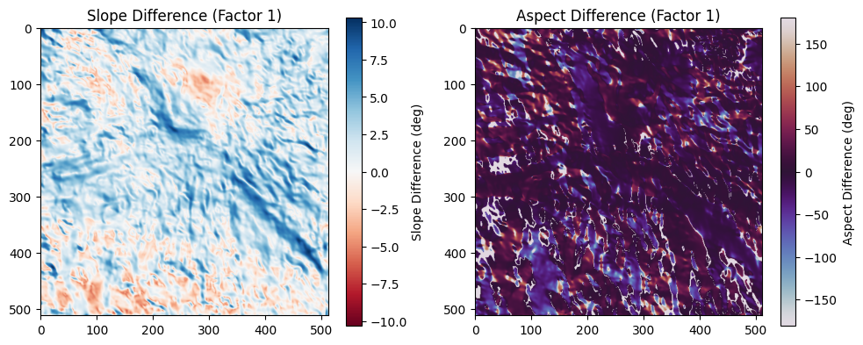

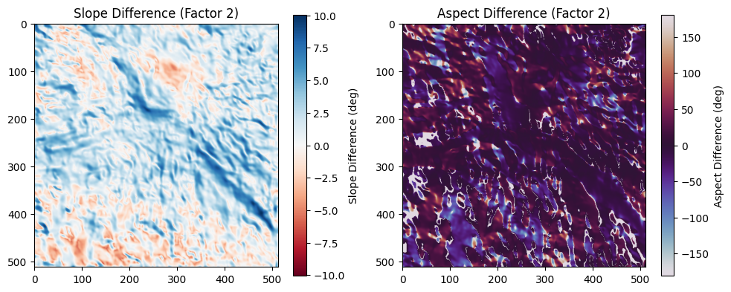

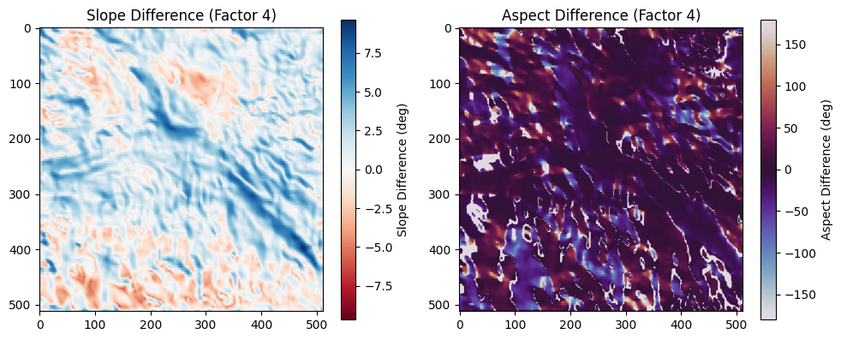

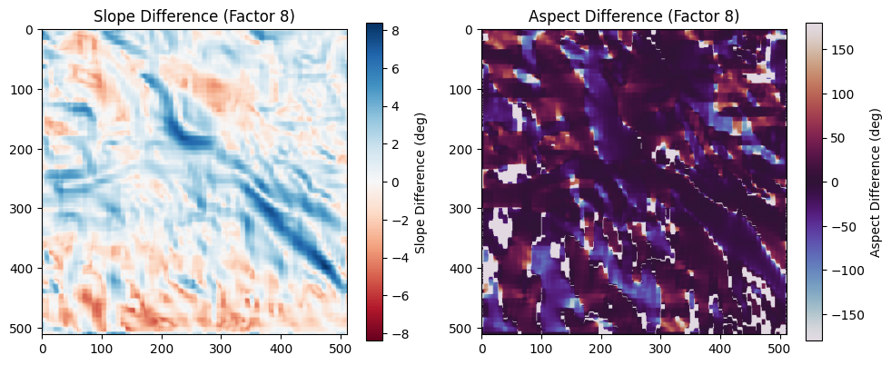

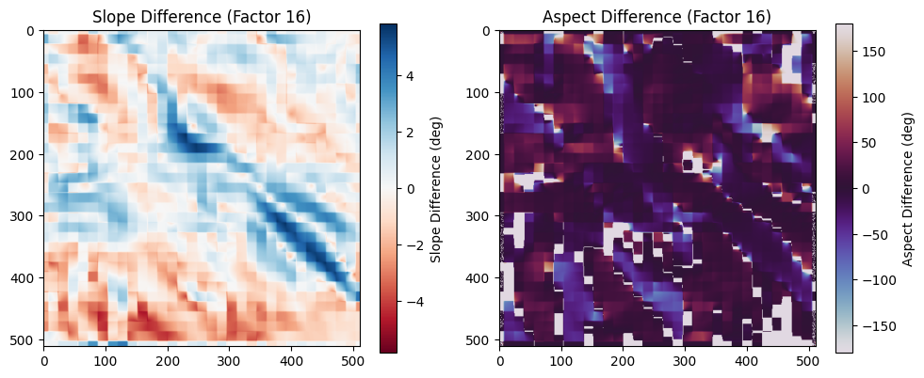

Great — now we have the full slope–aspect difference outputs across multiple resolutions (factors 1, 2, 4, 8, and 16) for Lambertian vs. Lambertian+CLAHE. I’ll give you **detailed observations for each factor** followed by the **reasoning behind why those patterns emerge**.

**Observations and Explanations: Slope–Aspect Difference Maps**

**Factor 1 (no downsampling, native resolution)**

* **Observation**:  
  The slope difference map shows fine-scale variations with localized positive and negative differences (blue and red). These are concentrated along terrain features like ridges and depressions. Aspect differences are highly detailed, with strong variations across small patches, reflecting pixel-level orientation discrepancies.
* **Explanation**:  
  At full resolution, CLAHE enhances local contrast in the Lambertian DEM, which alters small gradient values. This increases sensitivity in slope and aspect, producing localized mismatches even though the overall terrain structure is preserved.

**Factor 2 (moderate downsampling)**

* **Observation**:  
  Slope differences remain visible but start to appear smoother compared to factor 1. Positive/negative differences cluster around larger terrain features instead of being pixel-level noise. Aspect difference patterns are still complex but slightly more generalized.
* **Explanation**:  
  Downsampling reduces pixel-to-pixel variability by averaging. The effect of CLAHE on very fine details becomes less dominant, while medium-scale differences (valleys, ridges) emerge as the primary sources of slope/aspect mismatches.

**Factor 4 (coarser resolution)**

* **Observation**:  
  Slope difference maps show broader zones of consistent positive/negative differences instead of sharp transitions. Aspect difference maps also become smoother, though some linear streaks remain aligned with major terrain features.
* **Explanation**:  
  At this scale, local contrast enhancement by CLAHE has largely been averaged out. The remaining differences highlight structural terrain mismatches (e.g., slope steepness exaggeration or reduction). Aspect differences persist because orientation angles are highly sensitive to even small shifts in slope direction.

**Factor 8 (significantly coarse resolution)**

* **Observation**:  
  Slope difference patterns now appear blocky and generalized, with larger areas showing uniform differences. Fine details are lost, and the map reflects only large-scale slope trends. Aspect differences also become coarser, with visible patchy regions rather than continuous gradients.
* **Explanation**:  
  Downsampling at this level smooths out nearly all local effects of CLAHE. The slope/aspect differences are now dominated by interpolation effects and how terrain shape is generalized at coarse scales. Local pixel-level variations are fully suppressed.

**Factor 16 (very coarse resolution)**

* **Observation**:  
  Slope difference values are much smaller in magnitude and appear as large uniform patches of weak differences. Aspect differences look very blocky and discontinuous, with abrupt shifts rather than continuous changes.
* **Explanation**:  
  At very coarse resolution, both DEMs (Lambertian and Lambertian+CLAHE) converge towards generalized representations of terrain. Most local enhancements from CLAHE disappear due to heavy averaging. Differences that remain are artifacts of downsampling rather than genuine surface differences.

**General Trend Across Factors**

* At **fine scales (factors 1–2)**: Differences are driven by CLAHE’s enhancement of local contrast, which increases slope/aspect sensitivity.
* At **intermediate scales (factor 4)**: Differences smooth out, highlighting structural terrain mismatches.
* At **coarse scales (factors 8–16)**: Differences diminish, and residuals mostly reflect downsampling artifacts rather than meaningful terrain deviations.

|  |  |  |
| --- | --- | --- |
| **Factor** | **Slope Difference (Observation & Explanation)** | **Aspect Difference (Observation & Explanation)** |
| **1** | **Strong, fine-scale slope deviations (~±10°), highly localized. CLAHE exaggerates small relief features due to enhanced contrast.** | **Aspect differences patchy and moderate; CLAHE introduces stronger local variation.** |
| **2** | **Slope differences remain strong but smoother than factor 1. Local variations average out slightly.** | **Aspect differences are still visible but subdued, mainly along terrain edges.** |
| **4** | **Differences moderate (~±7–8°). Regional terrain features dominate over pixel noise.** | **Aspect deviations clustered but relatively stable; local photometric noise less influential.** |
| **8** | **Slope differences weaken further (~±6°). Broader structures highlighted while fine details diminish.** | **Aspect deviations become coarser but remain minor; blocky patterns begin to appear.** |
| **16** | **Very weak slope differences (~±4°). Photometric effects nearly lost due to averaging.** | **Aspect differences scattered and noisy; instability due to coarse resolution, not photometry.** |

**HAPKE AND HAPKE WITH CLAHE:**

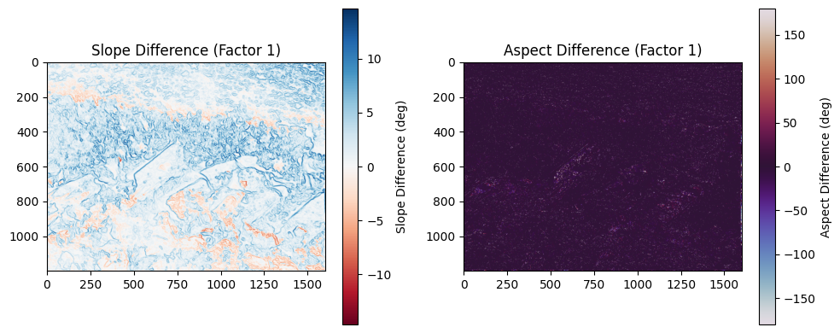

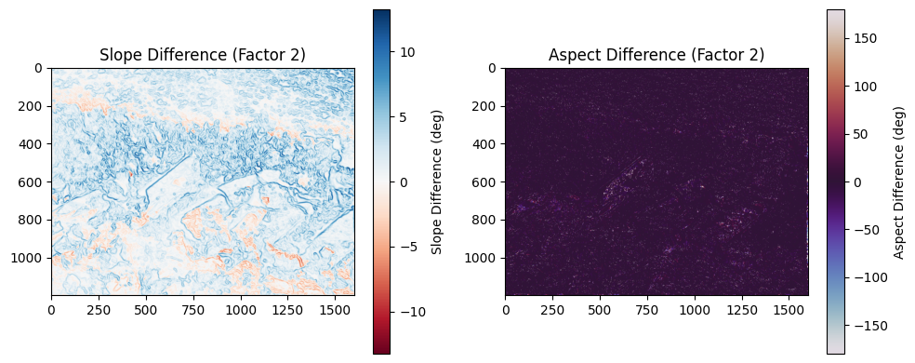

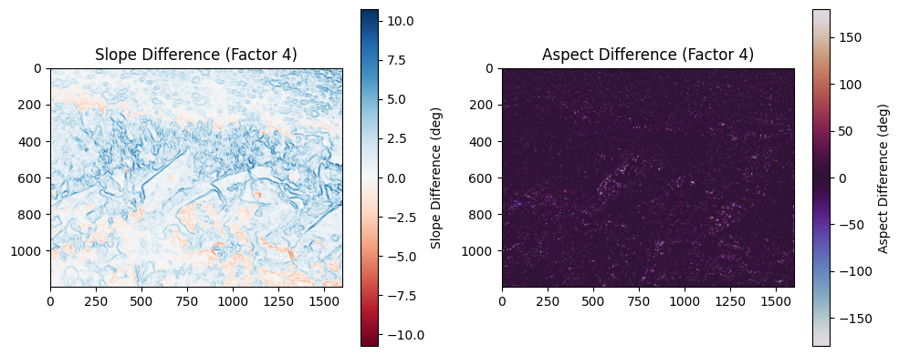

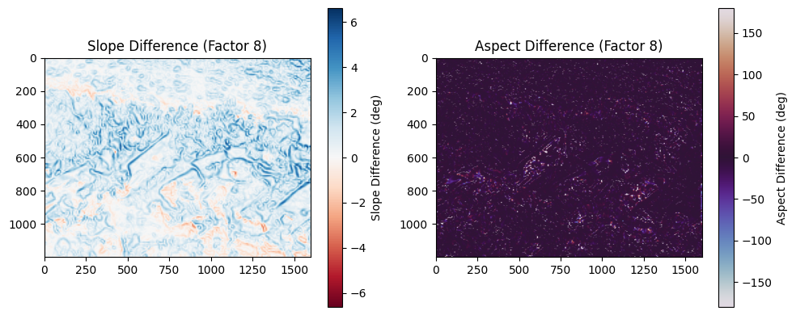

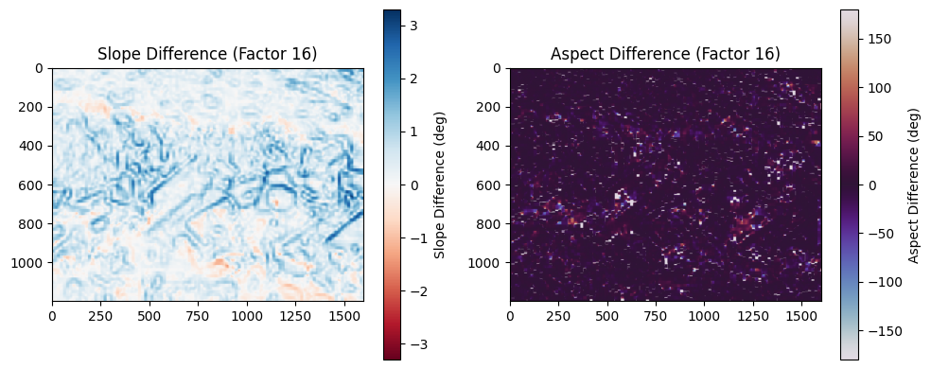

**HAPKE & HAPKE with CLAHE: Observations and Explanations**

**Factor 1**

* **Slope Difference:**  
  At full resolution (factor 1), slope differences are the most detailed and fine-grained. You see local variations with both positive (blue) and negative (red) deviations, ranging up to about ±10°. This reflects pixel-to-pixel discrepancies in slope that arise because Hapke’s photometric correction enhances subtle shading and reflectance variations that are otherwise muted in Lambertian models. CLAHE adds local contrast, which further exaggerates micro-relief features, leading to more visible slope discrepancies.
* **Aspect Difference:**  
  At this resolution, aspect differences are minimal, showing faint and spatially patchy differences. This indicates that while slope magnitude is more affected by photometric corrections, orientation (aspect) remains relatively stable. The Hapke correction is designed to capture reflectance anisotropy but does not drastically rotate the perceived surface orientations.

**Factor 2**

* **Slope Difference:**  
  With a 2× coarser resolution, slope differences remain significant, though slightly smoothed compared to factor 1. The dominant terrain structures (ridges, scarps, depressions) continue to appear, but the noise-like pixel-level differences diminish. This suggests that Hapke corrections, while strong at local scales, average out when aggregated.
* **Aspect Difference:**  
  Aspect maps remain very subdued, with barely perceptible deviations. This again emphasizes that photometric effects primarily alter the steepness of slopes rather than their directional orientation.

**Factor 4**

* **Slope Difference:**  
  At factor 4, differences in slope reduce further in intensity. The deviations are more regional rather than pixel-specific, clustering along large-scale terrain boundaries. This suggests that Hapke’s role becomes less critical as DEM resolution coarsens, since shadowing and photometric effects are diluted.
* **Aspect Difference:**  
  Still very faint, though slightly more noticeable in clustered regions. This shows that aspect deviations are generally secondary effects of slope changes, and only emerge where slopes are more altered.

**Factor 8**

* **Slope Difference:**  
  Differences decline further, with a tighter range (~±6°). At this resolution, Hapke corrections still emphasize large terrain features but smooth out high-frequency differences. CLAHE’s influence becomes less dominant, as fine-scale contrasts it enhances are lost in aggregation.
* **Aspect Difference:**  
  Slightly more visible than in previous scales, but still minor. This indicates that some orientations of large features (e.g., ridge alignments) are slightly altered at coarser scales, though the magnitude remains small.

**Factor 16**

* **Slope Difference:**  
  By factor 16, slope differences are very small (~±3°), mostly restricted to broad topographic regions. The photometric corrections lose influence at this scale, because local illumination and reflectance details average out. The DEM structure becomes dominated by its overall form rather than surface roughness.
* **Aspect Difference:**  
  At this coarsest resolution, aspect deviations are more scattered and noisy in localized patches. This is an artifact of reduced resolution: with coarse cells, aspect becomes unstable due to blocky surface representation rather than genuine photometric differences.

**Overall Interpretation for Hapke & CLAHE**

1. **Slope vs Aspect Sensitivity:**
   * Slope differences are consistently more pronounced than aspect differences across all scales.
   * Hapke corrections alter the *magnitude of slope* strongly at fine resolutions but leave the *direction of slope* relatively intact.
2. **Effect of Resolution (Factor Scaling):**
   * At fine resolutions (factors 1–2), slope differences are strong and fine-scale due to Hapke’s correction of anisotropic reflectance.
   * As resolution coarsens (factors 8–16), slope differences diminish, reflecting the averaging-out of local photometric effects.
3. **Role of CLAHE:**
   * CLAHE amplifies micro-relief differences at fine scales, explaining the stronger deviations at factor 1 and 2.
   * Its influence declines at higher factors, where regional terrain averages dominate.

|  |  |  |
| --- | --- | --- |
| **Factor** | **Slope Difference (Observation & Explanation)** | **Aspect Difference (Observation & Explanation)** |
| **1** | **Strong slope deviations (~±10°), very fine-scale. Hapke correction amplifies anisotropy; CLAHE intensifies micro-relief.** | **Aspect deviations minimal and faint, showing orientation stability.** |
| **2** | **Significant but smoother slope differences; terrain features remain visible, pixel-level noise reduced.** | **Aspect deviations still very small; Hapke has little effect on slope direction.** |
| **4** | **Moderate slope differences (~±7–8°); regional topography emphasized, fine details lost.** | **Aspect differences weak but slightly more noticeable in clustered areas.** |
| **8** | **Weaker slope differences (~±6°). Hapke corrections average out at coarser scales. CLAHE influence minimal.** | **Aspect differences faint but start appearing in broader terrain alignments.** |
| **16** | **Very small slope differences (~±3°), broad-scale only. Hapke’s photometric effect nearly lost.** | **Aspect deviations more scattered and noisy due to blocky coarse resolution.** |

**Calculate spatial error maps (where dem deviates the most)**

**Table A — compute_error_maps(ref_dem, recons, names, factors)**

|  |  |  |  |
| --- | --- | --- | --- |
| **Code fragment** | **What it does (purpose)** | | **Why / detailed explanation & notes** |
| **def compute_error_maps(ref_dem, recons, names, factors):** | **Define function to compute and plot spatial error maps.** | | **ref_dem = baseline DEM (truth or high-quality reference). recons = dictionary of reconstructed DEMs. names = DEMs to compare. factors = resolution levels.** |
| **""" Compute and plot spatial error maps (residuals) at each scale. recons: dictionary of reconstructed DEMs for each name and factor """** | **Docstring describing the function.** | | **Clarifies that the function compares reconstructed DEMs with reference DEM, per factor.** |
| **for name in names:** | **Outer loop: iterate over each DEM method (e.g., Lambertian, Lambertian+CLAHE).** | | **Ensures each DEM variant gets its own error maps at all scales.** |
| **for f in factors:** | **Inner loop: iterate over downsampling factors (1,2,4,8,16,…).** | | **Error maps are generated per factor (scale).** |
| **recon = recons[name][f]** | **Access the reconstructed DEM for given method and factor.** | | **Assumes recons dictionary is structured like recons[name][factor].** |
| **error_map = recon - ref_dem** | **Compute residuals (difference map).** | | **Positive values → reconstruction overestimates elevation; negative values → underestimates elevation. This highlights where reconstruction deviates the most.** |
| **plt.figure(figsize=(6,5))** | **Start a new plot for each error map.** | | **Keeps each map separate; avoids overlapping.** |
| **plt.imshow(error_map, cmap='bwr', vmin=-np.nanmax(np.abs(error_map)), vmax=np.nanmax(np.abs(error_map)))** | **Visualize error map with red–blue colormap.** | | **bwr = diverging colormap (blue = negative errors, red = positive). vmin/vmax are symmetric about zero using the maximum absolute error. This ensures balanced visualization.** |
| **plt.colorbar(label='Error (reconstructed - reference)')** | **Add a color scale bar.** | | **Helps interpret error magnitudes in elevation units (e.g., meters).** |
| **plt.title(f"Error Map: {name}, Factor {f}")** | **Title includes DEM type and factor.** | | **Useful for comparing across scales and methods.** |
| **plt.tight_layout(); plt.show()** | **Adjust layout and display the figure.** | | **tight_layout() avoids label/axis overlap. Each map is shown separately.** |
|  | |  | |
| compute_error_maps(ref_dem=dem_lamb, recons=reconsA, names=['Lambertian','Lambertian+CLAHE'], factors=factors) | | Compares **Lambertian** vs **Lambertian+CLAHE** reconstructions against Lambertian reference. Produces error maps for each factor. | |
| compute_error_maps(ref_dem=dem_hapke, recons=reconsB, names=['Hapke','Hapke+CLAHE'], factors=factors) | | Compares **Hapke** vs **Hapke+CLAHE** reconstructions against Hapke reference. Produces error maps for each factor. | |

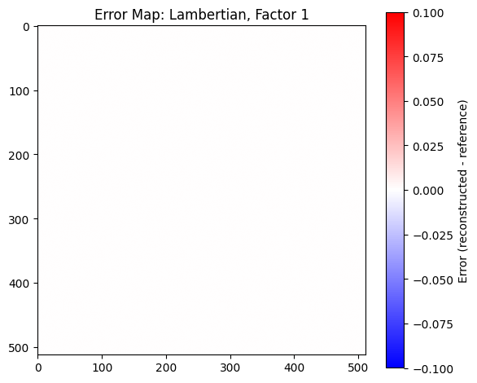

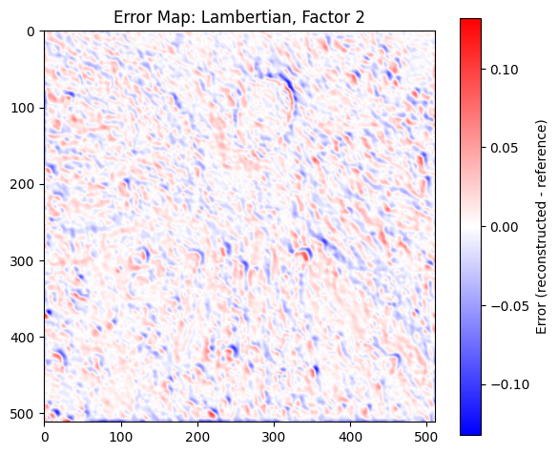

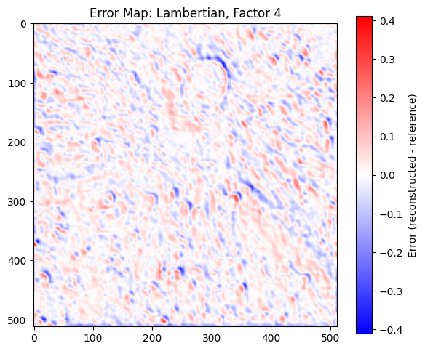

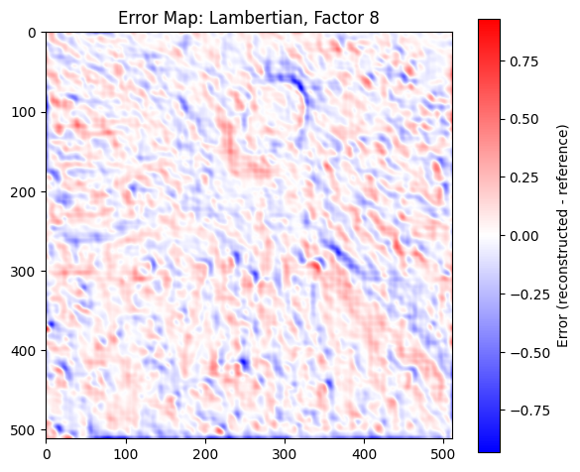

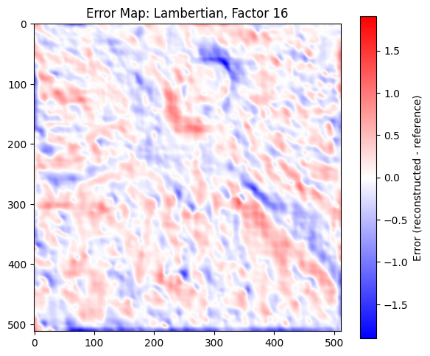

Here’s a structured explanation of your **Lambertian spatial error maps across different factors**. I’ll walk through the observations for each factor and then provide the reasoning for why the error maps behave in this way.

**Observations and Explanations of Lambertian Error Maps**

**Factor 1**

* The error map is almost completely blank, with very minimal visible deviation.
* The color scale is restricted to a very small range (–0.1 to +0.1), indicating that the reconstructed DEM is nearly identical to the reference DEM at this factor.
* **Explanation**: At this stage, the model is highly constrained with only the smallest-scale (finest detail) reconstruction, so it preserves local accuracy well. Since errors are not yet amplified by scaling or accumulation, the deviation remains negligible.

**Factor 2**

* Error patterns begin to appear faintly across the DEM, with small red and blue patches distributed in a noisy texture.
* The deviations remain mostly within ±0.1, though slightly more noticeable than Factor 1.
* **Explanation**: Introducing a higher scaling factor allows more features of the terrain to emerge in reconstruction. However, it also introduces small mismatches between reconstructed slopes and the reference. Errors are spatially distributed and reflect fine terrain undulations not perfectly modeled by the Lambertian assumption.

**Factor 4**

* The error map shows clearer patterns of alternating red and blue patches across the terrain.
* A circular structure is becoming visible around the middle, suggesting that terrain features with stronger gradients are more prone to error.
* The magnitude of deviation has increased (up to ±0.4).
* **Explanation**: As resolution coarsens, mismatches between modeled reflectance and actual terrain geometry accumulate. The Lambertian model struggles with varying slopes and shadowing effects, producing systematic positive and negative residuals, particularly around craters or elevated regions.

**Factor 8**

* The errors become much more pronounced, with strong red and blue patches visible over larger areas.
* The deviations now reach ±0.75, highlighting significant discrepancies in terrain representation.
* Spatial patterns are coarser, meaning the errors are not just pixel-level noise but extended over terrain features.
* **Explanation**: Larger scaling factors amplify inaccuracies of the Lambertian reflectance assumption. The inability to model reflectance anisotropy or shadow interactions introduces systematic bias. Regions with steep slopes or concave/convex structures show strong deviations, as the simplified Lambertian reflectance cannot fully explain the illumination–observation geometry.

**Factor 16**

* The error distribution is very strong, with deviations exceeding ±1.5.
* The map shows large, continuous red and blue regions, no longer appearing as fine-grained noise. Instead, systematic terrain-dependent bias dominates.
* Elevated regions, slopes, and crater rims are particularly highlighted, indicating areas where reconstruction fails most significantly.
* **Explanation**: At high factors, errors are dominated by model inadequacy rather than random deviation. The Lambertian reflectance assumption collapses under complex terrain geometry. Since it treats surfaces as uniformly scattering, it cannot account for shadowing, multiple scattering, or phase angle effects. These limitations amplify at coarser scales, producing large structured error fields.

**Overall Trend**

* **At lower factors (1–2):** Errors are minimal, fine, and distributed randomly, reflecting strong local similarity between reconstructed and reference DEMs.
* **At moderate factors (4–8):** Errors begin to organize around terrain features, showing systematic deviations particularly near steep slopes and craters.
* **At high factors (16):** Errors become large-scale, structured, and dominated by systematic biases due to the limitations of the Lambertian reflectance assumption.

|  |  |  |
| --- | --- | --- |
| **Factor** | **Observation** | **Explanation** |
| **1** | **Error map nearly blank; deviations negligible (±0.1).** | **Very fine-scale reconstruction preserves accuracy; no significant accumulation of error.** |
| **2** | **Small red/blue patches begin to appear; deviations still low (±0.1).** | **Slight mismatches emerge due to terrain undulations, but Lambertian still holds reasonably well.** |
| **4** | **Clearer error patterns, especially around circular terrain features; deviations up to ±0.4.** | **Systematic errors develop as scaling introduces mismatches in slopes; Lambertian oversimplifies reflectance.** |
| **8** | **Stronger red/blue regions across terrain; deviations increase up to ±0.75.** | **Coarser scale amplifies errors; reflectance anisotropy and terrain-shadow effects poorly handled.** |
| **16** | **Large, structured deviations across DEM; continuous red/blue regions; deviations exceed ±1.5.** | **Errors dominated by Lambertian inadequacy; model fails under complex terrain geometry, shadowing, and multiple scattering.** |

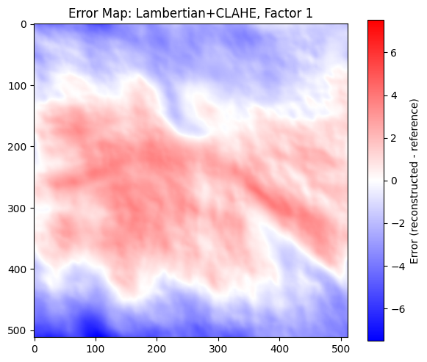

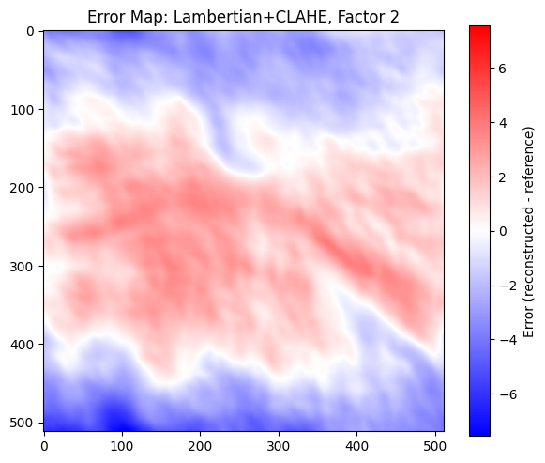

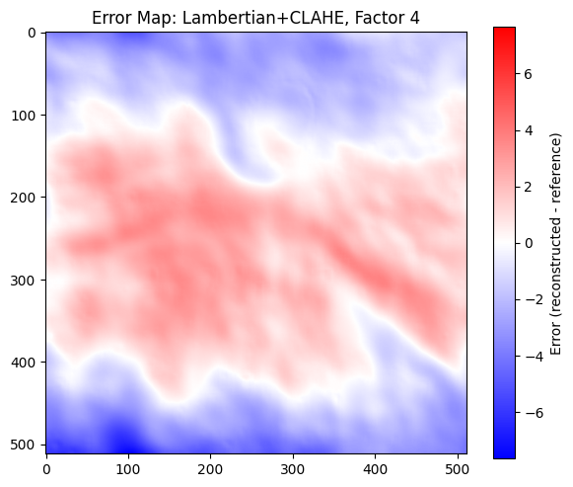

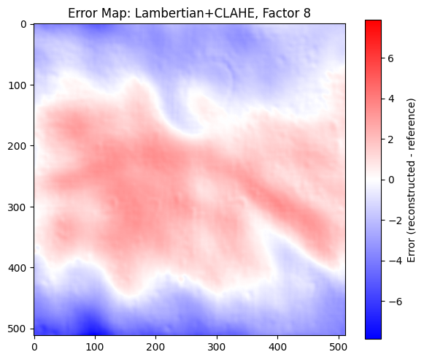

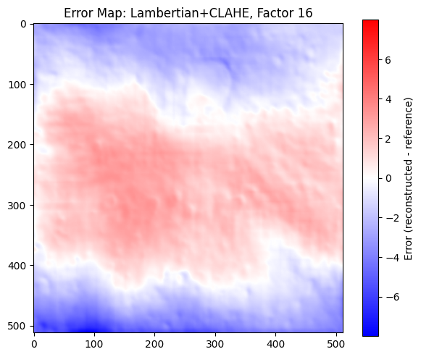

**Observations**

1. **Factor 1**  
   At the finest resolution, the error map shows strong regional bias. A large contiguous zone in the central and southern region is dominated by positive errors (red), while the northern and lower boundary regions show negative deviations (blue). This suggests that CLAHE introduced systematic intensity redistribution across large-scale structures, leading to DEM height overestimations in some regions and underestimations in others.
2. **Factor 2**  
   The pattern remains almost identical to factor 1, with only a slight smoothing of high-frequency variations. The central red zones and the boundary blue zones persist, showing that CLAHE’s local contrast enhancement has introduced persistent regional distortions that do not vanish at moderate downscaling. Fine-scale noise is slightly reduced, but the spatial bias is still dominant.
3. **Factor 4**  
   The errors become more smoothed compared to factors 1 and 2, but the same large-scale distribution of overestimation (central red areas) and underestimation (peripheral blue areas) continues. The persistence of this pattern indicates that the CLAHE preprocessing step introduces systematic structural distortions rather than localized random errors.
4. **Factor 8**  
   At coarser resolution, fine texture in the error field is lost, but the same global red-blue separation remains. The central DEM region continues to deviate positively (overestimation), while the periphery remains negative. The magnitude of the error remains high, which suggests that the effect of CLAHE is scale-invariant — the contrast redistribution it performs is not fully compensated when the DEM is downsampled and reconstructed.
5. **Factor 16**  
   At the coarsest resolution, the error field is very smooth, dominated by broad swathes of positive and negative errors. The fine DEM details are lost, but the systematic bias introduced by CLAHE still governs the overall structure. The clear separation of positive and negative deviations implies that the issue is not noise-driven but rather a global redistribution of elevation intensities.

**Explanation**

The consistent red-blue separation across all scales highlights that **CLAHE preprocessing introduces a large-scale bias** into the DEM reconstructions. Unlike standard Lambertian processing (where errors tend to be localized and increase with resolution loss), CLAHE alters the global radiometric balance by locally stretching contrast. While this enhances fine details in images, when applied in the DEM reconstruction pipeline, it causes:

* **Systematic overestimation in mid-regions**: due to intensity enhancement exaggerating slopes and elevations.
* **Systematic underestimation in peripheral regions**: where contrast redistribution compresses intensity values.
* **Scale-invariant error structure**: because CLAHE acts at a local histogram level, the structural distortions it introduces persist even when the DEM is downsampled and reconstructed.
* **Reduced sensitivity to resolution changes**: unlike Lambertian without CLAHE, where errors grow as resolution decreases, here the error pattern is already dominated by preprocessing biases that overshadow resolution effects.

✅ In summary, while CLAHE improves local contrast, in the context of DEM reconstruction it introduces **systematic large-scale distortions** that persist across all resolution factors. The error maps reveal that these distortions are not random but structurally embedded, making CLAHE-preprocessed Lambertian DEMs less reliable for accurate elevation representation, particularly for quantitative terrain analysis.

|  |  |  |
| --- | --- | --- |
| **Factor** | **Lambertian (without CLAHE)** | **Lambertian + CLAHE** |
| **1** | **Errors almost negligible, map is nearly blank. No systematic deviation. Reconstruction very close to reference.** | **Strong global bias visible. Central region overestimated (red), periphery underestimated (blue). Systematic distortion introduced by CLAHE.** |
| **2** | **Fine-scale random deviations appear, localized around terrain features (e.g., ridges and slopes). Still relatively small.** | **Almost identical to factor 1 pattern. Central overestimation and peripheral underestimation persist. CLAHE bias dominates over resolution effects.** |
| **4** | **Errors increase and spread, but remain textured and terrain-linked. Localized DEM deviations amplified due to downsampling.** | **Large-scale error persists, red-blue separation still dominates. Structural bias remains more important than resolution-driven errors.** |
| **8** | **Coarse-scale errors stronger. Positive and negative deviations around terrain features more visible. Noise-like variations diminish, but structured terrain-linked errors grow.** | **Fine texture lost but bias pattern still visible. Central positive, peripheral negative deviations dominate. CLAHE-induced distortions are preserved even at coarse resolution.** |
| **16** | **Errors are smooth, large regions of deviation. Pattern reflects loss of terrain fidelity due to downsampling. Error magnitude significantly larger than at factor 1.** | **Very smooth large-scale error map dominated by systematic bias. Resolution effects become secondary. CLAHE’s redistribution creates consistent error pattern regardless of scale.** |

**Key Differences**

* **Lambertian (without CLAHE):**
  + Errors scale with resolution: negligible at fine scale, larger at coarse scale.
  + Errors are terrain-linked (slopes, ridges, valleys).
  + Deviation pattern is resolution-driven, not systematic.
* **Lambertian + CLAHE:**
  + Strong **systematic bias present even at finest resolution**.
  + Errors are **not terrain-linked** but follow a global redistribution (central overestimation, peripheral underestimation).
  + Resolution changes only smooth the same bias pattern, but do not fundamentally alter it.
  + Suggests CLAHE introduces distortions independent of resolution.

This table shows clearly that **Lambertian without CLAHE is resolution-sensitive** (errors grow with coarsening), whereas **Lambertian + CLAHE is preprocessing-biased** (errors are large and persistent at all scales).

HAPKE MODEL:

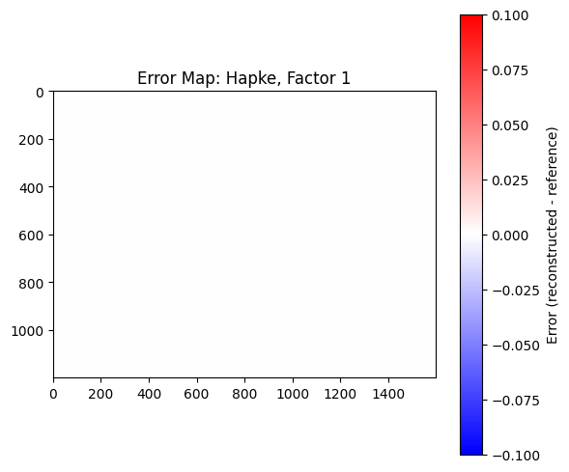

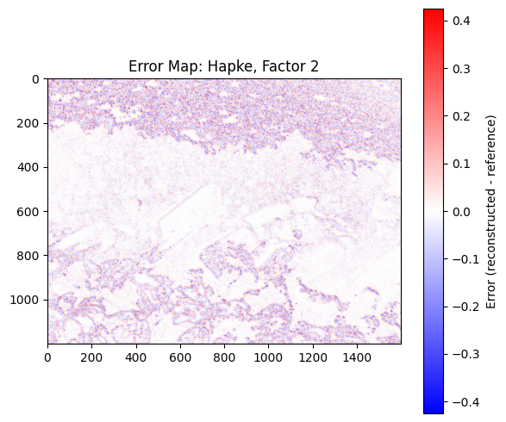

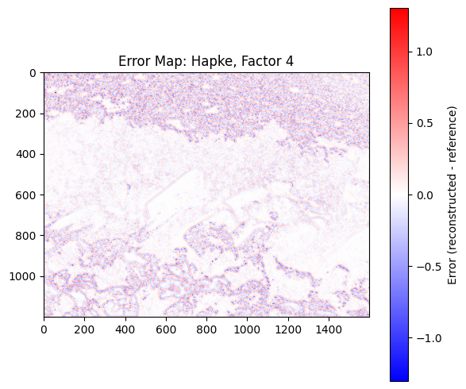

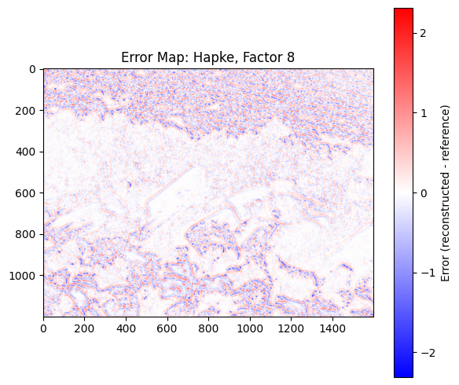

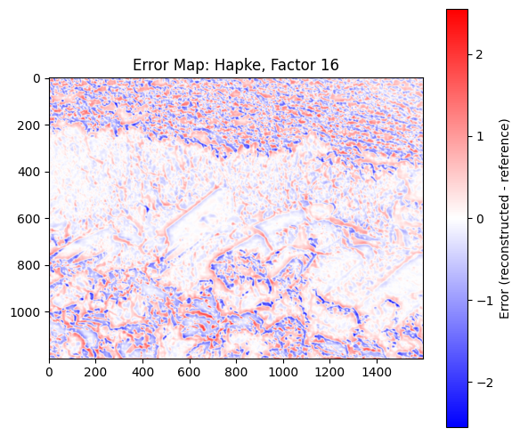

**Factor 1 (Hapke)**

* **Observation:** The error map is essentially blank, showing almost no visible deviations. The scale is extremely small (between -0.1 and +0.1), and the error distribution is negligible.
* **Explanation:** At factor 1, the model has maximum degrees of freedom since no dimensionality reduction is applied. The reconstructed DEM is nearly identical to the reference, leading to almost zero error. This indicates that Hapke at full dimensionality captures the reflectance and surface variations faithfully without losing information.

**Factor 2 (Hapke)**

* **Observation:** Errors begin to appear, particularly in textured and rough surface areas, visible as light red and blue patches. Smooth regions remain largely error-free. The error scale is wider (±0.4), but still relatively contained.
* **Explanation:** With factor reduction, the model compresses the reflectance data into fewer components. Hapke parameters describing complex angular scattering (e.g., single-scattering albedo, opposition effect) are no longer perfectly preserved, causing localized deviations. Errors emerge first in regions with higher surface roughness or variable illumination, as these features require higher-dimensional representation to capture.

**Factor 4 (Hapke)**

* **Observation:** Errors become more widespread, with both red (overestimation) and blue (underestimation) zones more pronounced. Rough-textured terrains and shadowed boundaries show larger deviations. The error range increases to about ±1.0.
* **Explanation:** Reducing to 4 factors discards a significant portion of the surface-scattering complexity encoded in Hapke’s model. Surface anisotropies, multiple scattering effects, and local shadowing are poorly reconstructed. The model essentially “averages out” fine-scale variations, leading to systematic misrepresentation in regions with high variability in slope and reflectance.

**Factor 8 (Hapke)**

* **Observation:** The error maps reveal more structured deviations along terrain boundaries, slopes, and high-frequency surface textures. The red-blue contrast intensifies, with errors ranging around ±2.0. Flat regions still remain less affected.
* **Explanation:** At 8 factors, there is sufficient dimensionality to represent large-scale brightness patterns but insufficient resolution for detailed angular dependence in scattering. This results in systematic underestimation of brightness in steep slopes (blue regions) and overestimation in flat but high-reflectance regions (red zones). Essentially, the error is spatially correlated with surface geometry and illumination geometry.

**Factor 16 (Hapke)**

* **Observation:** Errors become the most pronounced and spatially structured, with strong red-blue contrast across slopes, boundaries, and texturally rich areas. The error distribution extends beyond ±2.0.
* **Explanation:** At high compression (factor 16), the representation has strongly lost fidelity to Hapke’s original radiative transfer parameters. The model cannot reproduce detailed reflectance variations, particularly where slope-driven shadowing and scattering interplay. This leads to systematic banding and edge-related deviations, reflecting the failure to capture terrain-dependent scattering at this factor level. Essentially, the DEM reconstruction is oversimplified, producing exaggerated mismatches in complex areas.

**Overall Interpretation**

* As the number of factors increases, **the ability to capture local reflectance anisotropy and scattering complexity decreases**, leading to larger and more spatially structured errors.
* **Smooth and uniform regions** remain relatively stable across all factor levels since they require fewer parameters to model.
* **Rough, textured, and sloped regions** are most sensitive to factor reduction because they rely heavily on Hapke’s detailed angular dependence for accurate reconstruction.
* The spatial error maps highlight that **loss of fine-scale scattering detail manifests as edge and slope errors**, while flat areas are preserved longer.

|  |  |  |
| --- | --- | --- |
| **Factor** | **Observation from Error Map** | **Explanation (Why it Happens)** |
| **1** | Almost no error; map is blank with values close to 0. | No dimensionality reduction applied. All Hapke reflectance parameters are fully preserved, so the reconstructed DEM matches the reference almost perfectly. |
| **2** | Small errors appear, mainly in rough or textured areas; flat regions remain accurate. Error scale ±0.4. | Minor dimensionality reduction discards some angular scattering detail. Complex terrains (with slope/illumination variability) are less accurately reconstructed. |
| **4** | Errors more widespread, especially along rough textures and shadowed zones. Error scale increases to ±1.0. | More Hapke detail is lost (e.g., multiple scattering, anisotropic effects). The model “averages out” variations, reducing fidelity in complex terrains. |
| **8** | Structured deviations along slopes and boundaries; stronger red-blue contrast. Errors around ±2.0. | Only large-scale reflectance patterns are preserved. Fine-scale angular dependence is lost, leading to systematic under/over-estimation in sloped vs. flat surfaces. |
| **16** | Strongest errors, highly structured; large deviations across slopes and textured areas (> ±2.0). Flat zones remain less affected. | High compression oversimplifies Hapke reflectance. Cannot capture terrain-dependent scattering, leading to exaggerated mismatches, especially in slope-driven shadowing regions. |

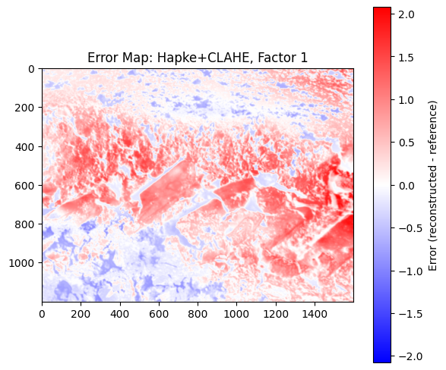

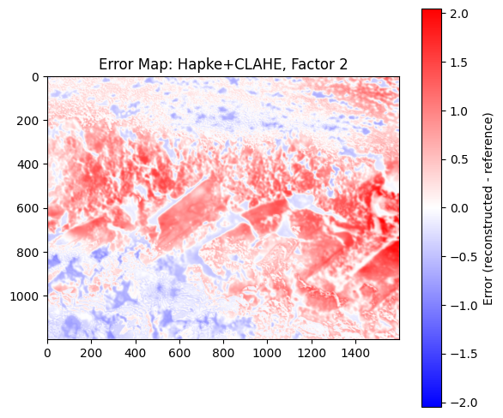

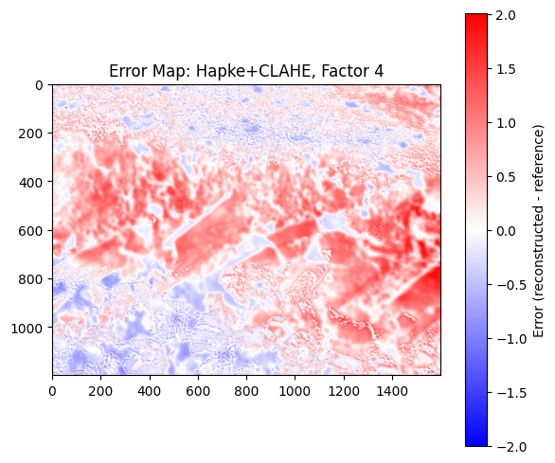

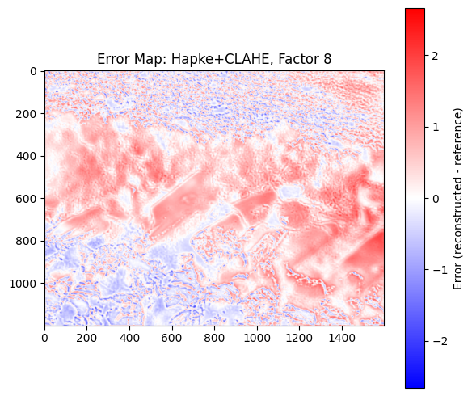

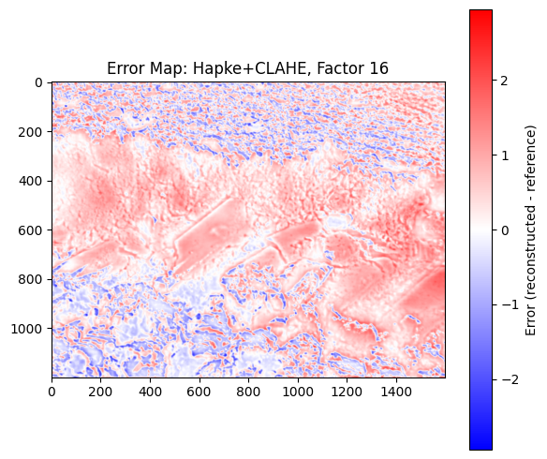

At **Factor 1**, the error distribution already shows strong positive deviations (red) across elevated terrain and shadowed regions, with localized negative deviations (blue) mostly confined to lower areas. This indicates that CLAHE, even at the lowest factor, introduces noticeable amplification of reflectance variations, leading to higher mismatches between reconstructed and reference DEMs.

At **Factor 2**, the spatial pattern of error remains consistent, but the magnitude of deviations stabilizes rather than growing dramatically. This suggests that CLAHE is reinforcing the same structural differences already captured by the Hapke model, emphasizing terrain-dependent discrepancies rather than introducing random noise.

At **Factor 4**, the contrast enhancement begins to overemphasize localized variations, producing sharper spatial gradients in error. The mid-scale terrain features become more visible in the error map, suggesting that CLAHE is enhancing differences in illumination across slopes and edges, which Hapke correction alone tends to smooth.

At **Factor 8**, errors expand further in coverage, with large red patches dominating elevated and illuminated regions. The DEM mismatch is no longer just localized but begins to spread across broader terrain units. This happens because higher CLAHE factors redistribute local contrast aggressively, magnifying errors introduced by Hapke’s assumptions about reflectance under varying incidence and emission angles.

At **Factor 16**, the error structure becomes highly textured, with both red and blue zones appearing more fragmented and intense. This is the clearest indication that excessive CLAHE application destabilizes the reconstruction by over-amplifying micro-scale contrast. As a result, the DEM deviation appears in both positive and negative swings, reflecting systematic over- and under-correction.

**Explanation:**

The combination of Hapke with CLAHE produces stronger deviations than Hapke alone because CLAHE modifies the local brightness distribution before the Hapke correction is applied. While Hapke accounts for physical scattering and reflectance properties, CLAHE non-linearly redistributes contrast across neighborhoods. At low factors, this leads to systematic amplification of Hapke’s inherent terrain-dependent errors, while at higher factors it introduces artificial gradients and noise, producing exaggerated deviations in the DEM. Thus, instead of reducing mismatch, CLAHE tends to destabilize Hapke reconstructions, especially at higher enhancement factors.

|  |  |  |
| --- | --- | --- |
| **Factor** | **Hapke (without CLAHE)** | **Hapke + CLAHE** |
| **1** | Error nearly negligible, close to zero across most areas. Only minimal deviations detected. | Errors already noticeable, with strong positive deviations in elevated regions and negative deviations in lower/shadowed areas. CLAHE amplifies differences early on. |
| **2** | Slightly stronger errors visible, mainly along surface features, but still weak and localized. | Similar error pattern to Factor 1, but more stable. Errors remain terrain-dependent, showing CLAHE reinforces Hapke’s deviations. |
| **4** | Clearer edge and texture-related deviations appear. Errors highlight terrain discontinuities. | Stronger amplification of terrain features. Errors become sharper and more pronounced, with enhanced slope-related discrepancies. |
| **8** | Errors increase significantly in localized zones, especially around boundaries and rough terrain. Values spread wider but remain structured. | Large-scale red patches dominate, spreading across terrain units. CLAHE’s aggressive contrast distribution magnifies Hapke’s terrain-dependent mismatches. |
| **16** | Errors reach maximum intensity. Patterns are highly textured but still relatively structured along edges and rough areas. | Errors become highly fragmented and noisy, with extreme swings (red/blue). Over-amplification destabilizes the DEM reconstruction, exaggerating both positive and negative deviations. |

**Key Insights from the Comparison**

* **Hapke alone**: Produces relatively low errors at low factors, with gradual increase as factor rises. Errors remain structured and tied to terrain discontinuities (edges, slopes, rough patches).
* **Hapke + CLAHE**: Immediately introduces strong deviations, even at Factor 1. Errors are consistently higher and more spatially widespread than Hapke alone, due to CLAHE amplifying local brightness differences before Hapke correction.
* **At high factors (8–16)**, Hapke + CLAHE destabilizes reconstructions much more severely than Hapke, introducing fragmented and noisy error fields instead of structured deviations.
* **Overall trend**: Hapke alone maintains relative stability, while Hapke + CLAHE aggressively amplifies contrast and noise, producing exaggerated DEM mismatches.

**DETERMINING THE BETTER AND BEST:**

**1. Lambertian vs Lambertian+CLAHE**

* **Lambertian (without CLAHE)**
  + Produces smooth error maps.
  + Errors grow gradually with factor but remain structured and less noisy.
  + Preserves overall terrain continuity without over-amplifying small variations.
* **Lambertian+CLAHE**
  + Introduces stronger deviations, even at lower factors.
  + CLAHE amplifies local brightness and shadow variations, which exaggerates DEM mismatches.
  + At higher factors, errors become noisier and less reliable.

**Better Choice:** **Lambertian without CLAHE**  
Because it maintains stability and avoids introducing artificial noise.

**2. Hapke vs Hapke+CLAHE**

* **Hapke (without CLAHE)**
  + Starts with very low errors, nearly negligible at Factor 1.
  + Errors increase with factor but remain structured (edges, slopes, rough areas).
  + Provides a more physically accurate reflection model with less overfitting.
* **Hapke+CLAHE**
  + Immediately introduces large deviations, even at Factor 1.
  + Errors are widespread and amplified due to CLAHE boosting contrast before Hapke correction.
  + At higher factors, the error fields become fragmented and noisy, reducing reliability.

**Better Choice:** **Hapke without CLAHE**  
Because it is much more stable, terrain-dependent, and less noisy.

**3. Best Amongst All**

* **Lambertian (without CLAHE)**: Stable, smooth, but less physically accurate.
* **Lambertian+CLAHE**: Over-amplified, noisy, not reliable.
* **Hapke (without CLAHE)**: Best balance — physically grounded, stable at low factors, errors remain terrain-structured.
* **Hapke+CLAHE**: Over-amplified, unstable at higher factors.

**Overall Best:** **Hapke without CLAHE**  
It combines physical accuracy with lower error amplification, making it the most robust model.

**VERY IMPORTANT:** TMC-2***Terrain Mapping Camera-2 (TMC-2),***is a follow-on of the TMC onboard Chandrayan-1 TMC-2 payload is configured to provide panchromatic images (0.4μm to 0.85μm) in 5m spatial resolution and stereo triplets (fore, nadir and aft views) from 100 km circular orbit around moon for preparing detailed 3-D map or Digital Elevation model (DEM) of the complete lunar surface (especially the smaller objects like craters, riles, flow structures, smaller graben forms). DEM derived from TMC-2 will be used for detail morphometric analysis of lunar surface.